1. begin—end with prompt:

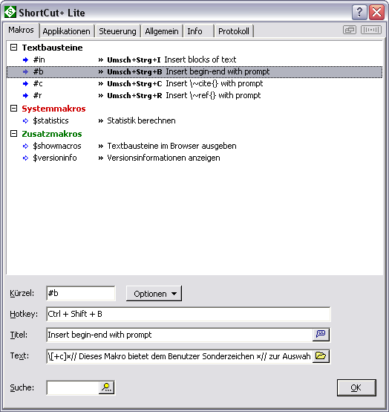

\[+c]

NAME:=input("","Enter the name of the environment:")
Result:="\\begin\{"+$NAME+"\}\n\ \n\b\b\\end\{"+$NAME+"\}\u";
echo Result;

2. \cite{} with prompt

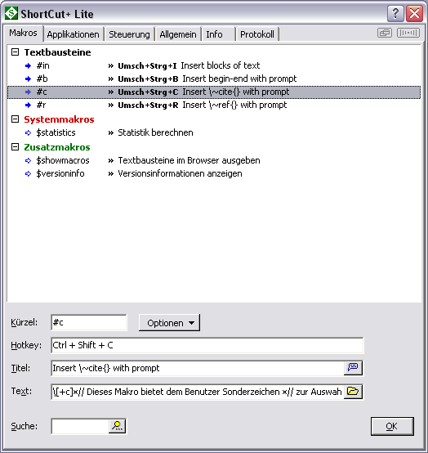

\[+c]
---------------------------

NAME:=input("","Enter the reference key:")
Result:="~\\cite\{"+$NAME+"\}";
echo Result;

3. \ref{} with prompt

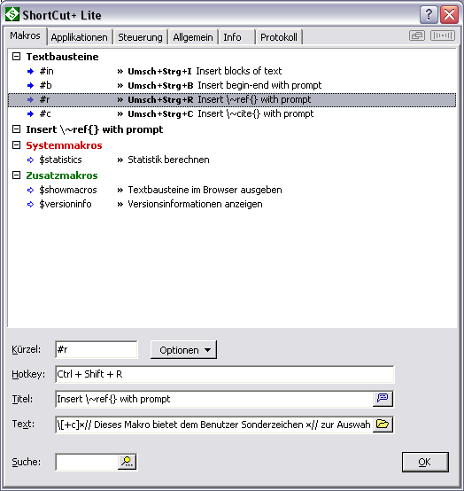

\[+c]

NAME:=input("","Enter the reference key:")
Result:="~\\ref\{"+$NAME+"\}";
echo Result;

4. Selection from menu (pasted items are not the ones which are shown)

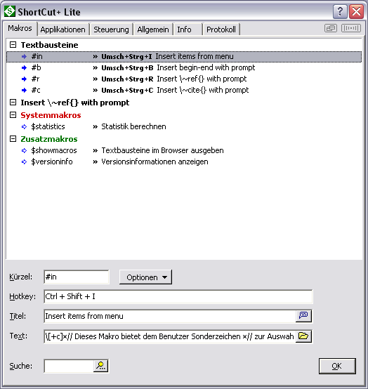

\[+c]
// Dieses Makro bietet dem Benutzer Sonderzeichen
// zur Auswahl an und gibt das gewählte aus.
// ----------------------------------------------

RESULT:="";
lists (KEYS,SZ)
"align" "\\begin\{align\}\n\ \n\\end\{align\}\l\l\l\l\l\l\l\l\l\l\l\b\b\l"
"cite" "~\\cite\{\}\l"
"ref" "\\ref\{\}\l"
"sub\upper script" "^\{\}_\{\}\l\l\l\l"
;
repeat (Z,KEYS) {
case KEYS[Z] RESULT:=SZ[Z];
break;
}
if (RESULT="") {
P:=popup(KEYS);
if P=-1 halt;
RESULT:=SZ[index(KEYS,P)];
}
echo RESULT;

5. float env

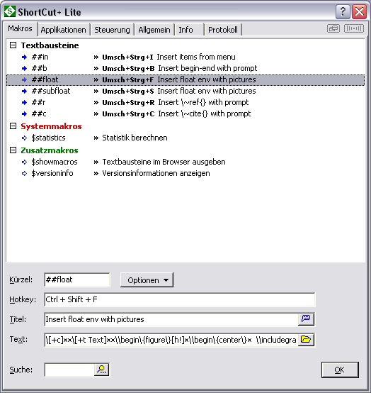

\[+c]

\[+t Text]

\\begin\{figure\}[h!]
\\begin\{center\}
\\includegraphics[scale=1]\{\}
\l\l\\end\{center\}
\\caption\{C\}
\\label\{fig:\}
\\end\{figure\}
\u\l\l

\[-t]

echo $Text

7. insert $$

\[+c]
\[+t Text]
$$ \l\l
\[-t]

echo $Text

6. subfloat env – multiple figs

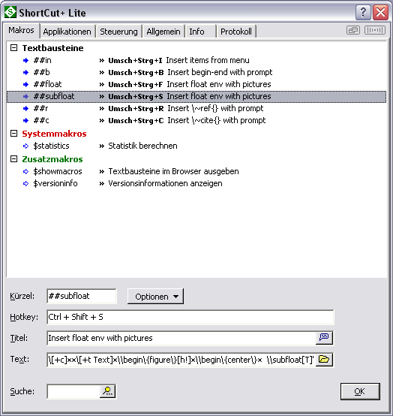

\[+c]

\[+t Text]
\\begin\{figure\}[h!]
\\begin\{center\}
\\subfloat[T]\{
\\includegraphics[scale=1]\{\}
\l\l\}
\\subfloat[T]\{
\\includegraphics[scale=1]\{\}
\l\l\}
\l\l\\end\{center\}
\\caption\{C\}
\\label\{fig:\}
\\end\{figure\}
\u\l\l
\[-t]

echo $Text

