CS 367 Tutorial
13 October 2008
Week 11 (tutorial #9)
Carl Schultz

Prolog
- a good debugging feature:
?- trace.

?- listing.

alive(_) :-
animal(frog).

animal(frog).

?- alive(X).
1 1 Call: alive(_383) ?
2 2 Call: animal(frog) ?
2 2 Exit: animal(frog) ?
1 1 Exit: alive(_383) ?
true ?

  - …and to turn it off use
?- notrace.

- to do arithmetic, use the “is” built-in relation
?- X is 5+3.
X = 8 ?

?- X is +(5,3).
X = 8 ?

?- Y is 5 + 3 * 11 - 44 / 8.
Y = 32.5 ?

  - …note: you need to give a variable to hold the result, e.g. “X is…”

- negation in prolog
  - real negation ¬ X means that “X is false”
  - prolog has a pseudo-negation that means “X is not provable”
  - the keyword is “\+”
  - E.g. using the above knowledge base:

?- \+ animal(frog).
no

?- \+ animal(book).
yes

  - this means that “animal(frog)” is provable (i.e. is in the knowledge base or can be inferred using the knowledge base)
  - “animal(book)” is not provable, so our “\+” operator returns true
  - BUT you will have problems if you put unbound variables in the “not” operator

?- \+ animal(X).
no

  - This can get really confusing if you have relations with unbound “not”s as goals. E.g. here’s a knowledge base:

raining_on(carl).
raining_on(jack).
wearing(jack, raincoat).
wet(X) :- \+ wearing(X,raincoat), raining_on(X).

  - You would expect that the following would return X=carl:
?- wet(X).
no
  - …but the “\+” fails as “wearing(X,raincoat)” can be satisfied (note: this can be fixed by swapping the order of “raining_on” and “\+ wearing”) – so be very careful with this

  - for more discussion visit
http://www.cs.sfu.ca/CC/SW/Prolog/Notes/negation.html

Lists in prolog

- e.g. [carl, 3, bat, 5, 8, [1,2,3,4,5] ]
- elements can be anything, including other lists
- empty list is: [ ]
- non-empty list has two main parts: head (singleton) and tail
- formally, lists are structured data objects, with name “.” and arity 2, e.g.
?- [3] = .(3,[]).
yes
?- [3,x] = .(3, .(x,[])).
yes

- prolog uses special notation to specify items at the beginning of the list and then leave the rest of the list unspecified, “[head₁,…, head_{n} | Tail]”
?- [3,4,5] = [3|Tail].
Tail = [4,5] ?

?- [3,4,5] = [3|_].
yes
| ?- [3,book,zoo] = [3,book|_].
yes
| ?- [3,book,3,4,5,6,7] = [3,book|_].
yes
?- [3,book] = [3,book|_].
yes
| ?- [1,book,red] = [_,book|Tail].
Tail = [red] ?
?- [alpha,beta,5,6,7] = [_,_|[5,6,7]].
yes

- Lists are defined inductively
list([ ]).
list([I|L1]) :- list(L1).

  - …that is, a list has a singleton item at the head (I) and a list for a tail (L1)
  - E.g.:

.(3,[]). … I=3 and L1=[]
.(3, .(x,[])). … I=3 and L1=[x]

- because lists are defined inductively, so are operations
  - member/2 - returns true if item is a member of the list

?- member(3,[x]).
no
| ?- member(3,[3,x]).
yes

    - base case: check first item in list

member(Item, List) :- List = [Item | _ ].

    - inductive step (if base case fails): check tail

member(Item, List) :-
List = [ _ | Tail ],
member(Item, Tail).

    - we can be more concise in our code:

member( I, [ I | _ ]).
member(I, [ _ | T ]) :- member(I, T).

  - conc/3 - concatenate first list on to front of
second list and return as third list

?- conc([3,x],[y], L).
L = [3,x,y] ?

    - base case: first list is empty, then result equals second list

conc([], L2, L2).

    - inductive step (if base case fails): keep plucking the head off of the first list and put it on the front of the result (eventually L1 will be empty and we hit the base case)

conc([ I | L1], L2, [I|L3]) :- conc(L1, L2, L3).

    - can use in all sorts of ways, e.g.:

?- conc([3],L2,[3,x,y,v,a]).
L2 = [x,y,v,a] ?

?- conc(L1, L2, [1,2,3]).
L1 = [],
L2 = [1,2,3] ? ;
L1 = [1],
L2 = [2,3] ? ;
L1 = [1,2],
L2 = [3] ? ;
L1 = [1,2,3],
L2 = [] ? ;
no

A* and IDA*

- Informed search means it uses additional information, not just the problem specification – one example is heuristics, i.e. guessing how far a node is from the nearest goal node

- Greedy best-first search expands node with lowest estimated cost (remember the heuristic is only a guess – no guarantees that the guess is correct)

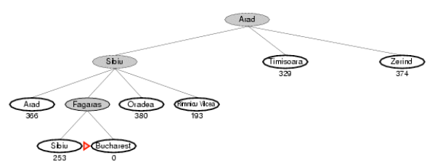

- A* search tries to avoid expanding paths that have already got a high cost

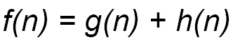

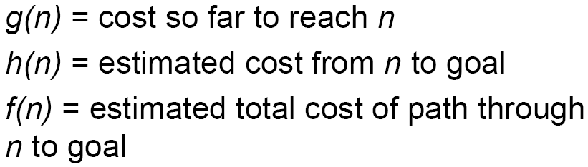

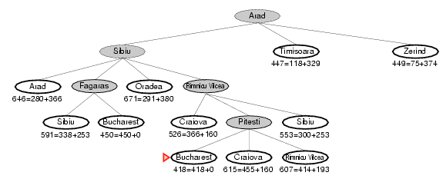

  - A* finds the best solution if heuristic h(n) is admissible
    - admissible = heuristic is optimistic
    - it means that the heuristic cost will always be less than or equal to the real cost

  - to understand why the solution is always optimal, consider the following:
    - A* has found a goal node
    - by A*’s definition, it is the node that has the lowest path cost:
      - g(n)+0 (from root to goal node – nb: h(goal)=0)
    - …compared to any other open nodes:
      - g(n)+h(n) (nodes that are ready to be visited)
      - if this wasn’t the case, then A* would have visited some other open node instead (i.e. uses f(n))

    - BUT what if some other lower cost path exists through one of the other open nodes that we haven’t explored?
      - i.e. what if some other path exists through node m so that:
      - g(n)+0 > g(m)+h*(m) h*(m) means real cost from m to goal

    - this can never happen, because the heuristic is optimistic – i.e. the actual cost will be BIGGER than or equal to the estimated cost
      - i.e. h(m) ≤ h*(m)

    - …and the estimated cost is BIGGER than or equal to the real cost of the path we took
      - g(n)+0 ≤ g(m)+h(m) ≤ g(m)+h*(m)

- big problem with A* is memory
  - holds all expanded nodes in memory (this can be exponential!)
  - so, use Iterative-deepening A*
    - same relationship as iterative-deepening and breadth-first
    - (recommended to review iterative deepening slides)
    - Set an f(n) limit, run a depth-limited search (but limiting by cost using A* trick of f(n)=g(n)+h(n)), if fails then increase limit and try again:
      - start with bound=f(root)
      - run depth-first search – but backtrack when f(n) > bound
      - if search can’t find anything, then start again with bound+=d
(where “d” is some increment)
      - …
  - Here’s a good summary
http://www.inf.uos.de/papers_html/ai_94/node2.html

