CompSci 210 S2 C
- Assignment One -

The work done on this assignment must be your own work. Think carefully about any problems you come across, and try to solve them yourself before you ask anyone else for help. Under no circumstances should you work together with another student on any part of this assignment.

Due Date

Due: Sunday 11th September 2016 11:59 pm
Worth: 10% of total CS.210 marks

Aim of the assignment

The aim of this assignment is to ensure you understand the content of the first half of the semester. The assignment is in multiple parts – you will not be able to answer the later parts of the assignment until that material has been covered in the lectures and tutorials.
Fill out your answers in the spaces provided below and submit this document along with two LC-3 .asm files (for questions 12 & 13) in a single .zip file through the Assignment Drop Box https://adb.auckland.ac.nz/
Your Name: ________________________ Your UPI: ___________
Question 1
Name one characteristic of natural languages that prevents them from being used as programming languages.
[2 marks]

Question 2
Two computers, A and B, are identical except for the fact that A has a subtract instruction and B does not. Both have add instructions. Both have instructions that can take a value and produce the negative of that value. Which computer is able to solve more problems, A or B? Explain your answer.
[4 marks]

Question 3
Suppose you go online and buy a word-processing application. What format is the software actually in? Is it in a high-level programming language? Is it in assembly language? Is it in the ISA of the computer on which you intend to run the software? Justify your answer.
[4 marks]

Question 4
Given n bits, how many unsigned integers can be represented with the n bits? What is the range of these integers? [4 marks]

Question 5
Convert these decimal numbers to 8-bit 2’s complement binary numbers.
- 102
- 64
- 33
- -128
- 127
[5 marks]

(a)

(b)

(c)

(d)

(e)

Question 6
Describe what conditions indicate an overflow has occurred when 2’s complement numbers are added.
[4 marks]

Question 7
Convert the following hexadecimal representation of 2’s complement binary numbers to decimal numbers.
- xF0
- x7FF
- x16
- x8000
[8 marks]

(a)

(b)

(c)

(d)

Question 8
Define a new 8-bit floating point format with 1 sign bit, 4 bits of exponent, using an excess-7 code (that is, the bias is 7), and 3 bits of fraction.
If xE5 is the bit pattern for a number in this 8-bit floating point format, what value does it have? (Express as a decimal number)
[10 marks]

Question 9

a. Fill in the truth table for the logical expression NOT(NOT(A) OR NOT(B)).
[4 marks]

A | B | NOT(NOT(A) OR NOT(B))
0 | 0
0 | 1
1 | 0
1 | 1

b. What single logic gate has the same truth table?
[1 mark]

Question 10
Given the logic circuit below, fill in the truth table for the output value Z.
[8 marks]

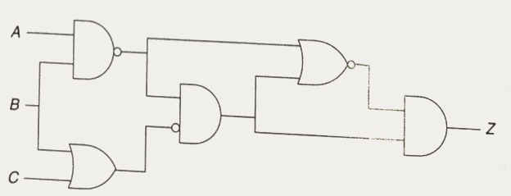

A | B | C | Z
0 | 0 | 0
0 | 0 | 1
0 | 1 | 0
0 | 1 | 1
1 | 0 | 0
1 | 0 | 1
1 | 1 | 0
1 | 1 | 1

Question 11
The following table represents a small memory. Refer to this table for the following questions.

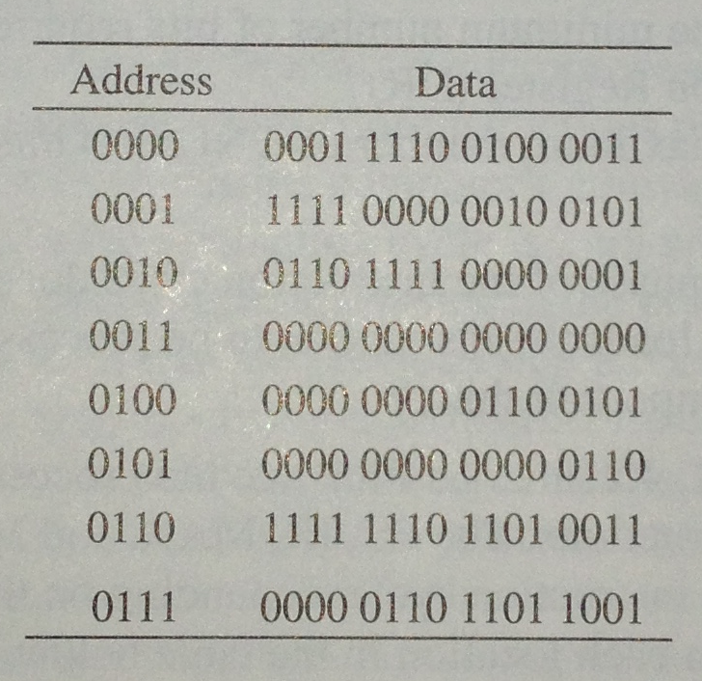

- What binary value does location 3 contain? [1 mark]
- The binary value within each location can be interpreted in many ways. You have seen that binary values can represent unsigned integers, 2’s complement signed integers, floating point numbers and so forth.
1) Interpret location 0 and location 1 as 2’s complement integers. [2 marks]
2) Interpret location 4 as an ASCII value. [2 marks]
3) Interpret locations 6 and 7 as an IEEE floating point number. Location 6 contains number [15:0] and location 7 contains number [16:31]. [5 marks]
4) Interpret location 0 and location 1 as unsigned integers. [2 marks]
- In the von Neumann model, the contents of a memory location can also be an instruction. If the binary pattern in location 0 were interpreted as an instruction, what instruction would it represent? [2 marks]
- A binary value can also be interpreted as a memory address. Say the value stored in location 5 is a memory address, to which location does it refer? What binary value does that location contain? [2 marks]

(a) Location 3 contains
(b)
i. Two’s Complement -
Location 0 =
Location 1 =
ii. ASCII - Location 4 =
iii. Floating Point -
Locations 6 and 7:
The number represented is
iv. Unsigned -
Location 0 =
Location 1 =
(c) Instruction - Location 0 =
(d) Memory Address
- Location 5 refers to
- The value stored is

Question 12
Write an LC-3 program that compares the two numbers in R1 and R2 and puts the value 0 in R0 if R1 = R2, 1 if R1 > R2 and -1 if R1 < R2.

(Name this program file Q12.asm)
[15 marks]

Question 13
Write a short LC-3 program that asks you to input your name and then prints it to the console in the following manner.

Please enter your name (less than 100 characters long):
David
Hi David, have a good day.

(name this program file Q13.asm)
[15 marks]

________________

