Methodologies for cross platform RIA porting between Flex/Java and Silverlight/Microsoft .NET
BTECH 450
End of First Semester Project Report

Jason Wei-Lun Hsia
Department of Computer Science
University of Auckland

Supervisors
Industry Mentor:
Chris Skilton
Futuretech
New Zealand
Academic Mentor:
Dr. Xinfeng Ye
University of Auckland
New Zealand

Department of Computer Science, University of Auckland, Auckland, New Zealand

jhsi014@aucklanduni.ac.nz

Abstract. The topic of my BTech project is researching on the two most popular Rich Internet Application (RIA) frameworks/languages—Adobe Flex and Microsoft Silverlight. This report discusses on the similarities and differences between the two frameworks using code samples, and the future works of the project, which needs to be done for the next semester
Keywords: Adobe, Flex, Flash, Microsoft, Silverlight, RIA, Rich Internet Application, porting

Table of Contents
1 Introduction 4
1.1 About Company 4
1.2 About RIA 4
1.3 Motivation 5
1.4 Project Goal 6
2 Technologies 7
2.1 Rich Internet Application (RIA) 7
2.2 Adobe Flex 8
2.3 Microsoft Silverlight 8
2.4 Similarities and Differences 9
2.5 Advantages and Disadvantages 12
2.6 Learning Resources 13
3 Conclusion 14
3.1 Future Work 15

4 References 15

1 Introduction
This report documents the information about the BTech 450 project that I am currently doing for a company called Futuretech. The project is to research on the methodologies of porting application from Flex to Silverlight.
1.1 About Company
The company that is supporting me in this project is called Futuretech. Craig Meek founded Futuretech in 2008 and is a specialist in visual communication. The company specializes in data visualization, and has been working closely with HP R&D programmes to produce visual business intelligence products, which are all based on the Adobe Flex framework.
1.2 About RIA
Rich Internet Applications (RIA) is the modern trend in Internet programming. It has gradually becoming the mainstream within businesses, and slowly replacing the traditional HTML web pages as they have the advantage of being more attractive, viable, and provide developers a richer range of controls, functions, and features to work with.

Rich Internet Applications are web applications that have many of the characteristics of desktop applications. They allow programmers to develop applications that are cross platform, as they are supported through Internet browser plug-ins or virtual machine environments.

For many years the predominant RIA framework has been Adobe’s Flash engine. This can arguably be primarily attributed to the vast acceptance and proliferation of the Flash Player plug-in. Microsoft joined the RIA battle in 2007 with a RIA platform called Silverlight. Since Silverlight v1 was released, Microsoft have continued development of the platform releasing version two, the incumbent version three, and are poised to release version four final in coming months. They have packaged the Silverlight plug-in with the latest versions of Internet Explorer and have made a commitment to establishing versions of the plug-in for Mac, Linux, and mobile platforms including Symbian. Microsoft are rapidly becoming a serious contender for RIA dominance, heading for a showdown of sorts with Flash, and are perhaps politically advantaged within Enterprise thanks to a history business orientated support products, tools, and applications.

The emergence of Silverlight as a genuine threat to Flash, and Adobes flagship RIA framework Flex, has given those specializing in RIA development much to think about. Namely, should suppliers of RIA technology be reconsidering their choice of platform, and if they are to make the switch, how can they efficiently port their Intellectual Property into an alternative framework, whilst still maintaining core application architecture? In addition to this consideration, there is likely to be a period of time within which each RIA platform choice offers advantages over the other, and navigating through this period of turbulence will require a clear strategy and keen. During this period it may be advantageous for RIA developers to consider bridging between Silverlight and Flex, maintaining two distinct code bases simultaneously.
1.3 Motivation
Over the past few years Microsoft had been pushing the development of Silverlight, hoping that it catch up with the more popular RIA framework—Adobe Flex. (Just over 3 years from their first release, Microsoft has just released Silverlight 4) In many aspects, the Silverlight has achieved that goal; it provides similar functionalities to those in Flex (Flash), such as integrating multimedia, graphics, animations, and interactivity features.

Due to the rapid growth of the Silverlight framework, there has been an increase in market demand for Silverlight applications. Thus, it really has caught companies eyes to make a move or looking into the possible transitions from other RIA framework developments into Silverlight developments. There has been an increase in market demand for Silverlight applications. The company has getting more and more enquiries about the Silverlight-based products from their clients.

Thus the company would like to be able to some kind of documentation or guideline to enable them to create the building blocks of a Silverlight powered equivalent of their Flex based applications. They have a real-world requirement for such and suspect that there are many companies with investment in one platform or the other that would like to mitigate risk of commitment also.

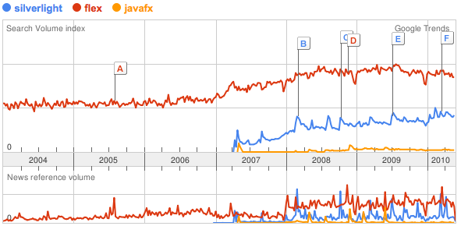
Figure 1 Google Trend analysis on the 3 most popular RIA platforms
1.4 Project goal

The main goal of the project is to do research on Rich Internet Application (RIA) frameworks/languages—Adobe Flex and Microsoft Silverlight especially. From the information gathered, then define a set of processes and policies to enable the company to create the basis of a Silverlight version of the company Flex based software applications. It outlines a methodology and process for synchronous code base porting of MXML to XAML, AS3 to C#, Java to C#, AMF to SOAP, etc. In addition it discusses the best graphic design applications for design assets to support both RIA frameworks.

Since the RIA market has been dominated by the Flash/Flex framework in the past, most of the RIA software development companies have based all their development in Flex. So as the ultimate goal of this project, in terms of helping the business, is to port the Flex based source codes into the equivalent Silverlight version codes.

There is no guarantee that either RIA framework will greatly outshine or outlast the other; in actual fact many insiders also consider the development of HTML 5 and CSS 3 to break RIA out of its plug-in sandbox. Many opinions reside, but the company’s collective opinion focuses on the likelihood of Silverlight v4 giving them good reason to port their applications from the Flex/Flash 4 SDK, maintaining parallel development in both platforms without having to duplicate 100% of their effort.

From the academic point of view, it will be focused on comparing and contrasting the features of the two Rich Internet Application (RIA) frameworks—Flex and Silverlight. These include the usability, portability, and performance. If time allows, it might be interesting to look into JavaFX—Java’s RIA framework.

2 Technologies & Development Tools
The main focus of technology in this project is obviously the Rich Internet Application (RIA). The project will investigate the two RIA frameworks—Flex and Silverlight.

2.1 Rich Internet Application (RIA)
Most RIA frameworks use the Model-View-Controller (MVC) as their software architectural where the applications developed under these frameworks are broken down into separate layers—data model, user interface (view), and the business logic (controller). In this architecture, the model is responsible for the gathering of data, the view presents the data from the graphically and receives user inputs, and the controller is responsible for processing the user request from the UI controls, and updates the model accordingly.

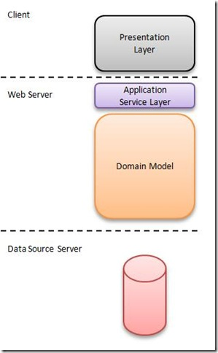
Figure 2 Typical RIA architecture

2.2 Adobe Flex
The research work I have done on Flex is looking into the basic data types, user interface controls, and the functionalities. Flex is one of the earliest RIA platforms, and remains the most popular RIA platform today. It uses MXML and ActionScript

Since the update from Flex 3 to Flex 4, there has been a new framework in place for Flex on top of the existing MX framework—Spark Framework. The advantage of the spark framework over the old MX framework is the separation of visual controls and the application logic.
2.3 Microsoft Silverlight
The research work I have done on Flex is looking into the basic data types, user interface controls, and the functionalities. Silverlight basically uses the Windows Presentation Foundation (WPF), but in a smaller package version, and is missing some features and controls that are found in the WPF framework. It only uses a faction of the entire .NET Base Class Library. However, that is essentially what Silverlight aims to do—a lightweight, cross-platform and a lightweight client.
2.4 Similarities and Differences
Adobe and Microsoft have each released useful and popular IDE tools to develop application in their own RIA frameworks. In the Silverlight development environment there are two main development tools (IDE) that most people use to build Silverlight applications—Microsoft Visual Studio and Microsoft Blend. Then there is Adobe Flex Builder to develop Flex framework applications.

The two RIA frameworks have a lot of features and function in common. Mainly because Flex has been dominating the RIA market before Silverlight was released (Flex is still the most popularly used RIA platform, but Silverlight is slowly but gradually increasing in the market), thus it became necessary for Silverlight to replicate the same features and architecture of Flex.

Source File architecture

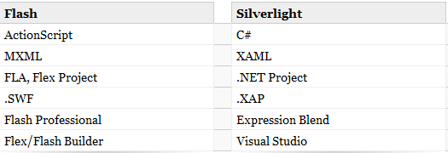
Figure 3 Comparison table for the two RIA frameworks on the different RIA components

In the figure above, it shows the equivalent components in RIA between the two frameworks. First of all, both frameworks use a markup language to visually represent data structures that will be parsed and translated into code. For Silverlight it is XAML files, and MXML for Flash.
According to the research and development I have done, XAML seems to be the more complex markup language compared with MXML—it contains more details, and well designed, but might be harder to use and takes longer to learn compared with MXML

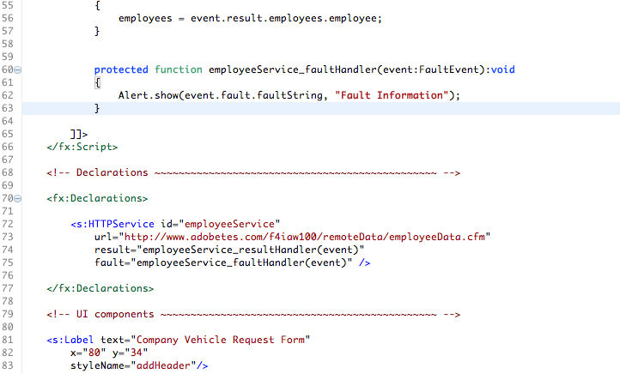
Figure 4 MXML code with ActionScript

Development Environments/Tools

Lets start off talking about Silverlight, from my own programming experiences, Silverlight development is really easy to grasp if you are familiar with the C# programming and the Microsoft .NET framework. As mentioned before in the report, Silverlight uses a scaled down version of the .NET framework, and it uses C# to implement the business logics behind the user interface controls. (May be used to program entire applications including UI)

Data Binding

In my research, data binding seems to be the most obvious area that Silverlight and Flex are different to each other. Silverlight’s approach in data binding is more strict and robust, whereas Flex takes a much looser approach. However, this also means that Silverlight is harder to code, and Flex provides a bit more flexibility.

2.5 Advantages & Disadvantages

Both frameworks has got their own advantages and disadvantages, it is still unclear which is the clear winner. First of all, Flex has the advantage of having high market share, as it has been around basically ever since RIA is used, almost every computer in the world has got Flash player plug-in installed [2] (95% to be exact). Also, Flex development tools are supported in both Mac OS and Windows, whereas Visual Studio and Blend (Silverlight’s IDE tools) are only available in Windows OS.

Another advantage of Flex, again due to its popularity over the past years, it has a large range of IDE development tools available—Flash Development Tool, ActionScript Development Tool, FlashDevelop, SE|PY, ANT builds, and more. However, according to many articles and in terms of tool functionalities, Microsoft Blend seems to have an edge over the Flash Catalyst, in designing and constructing RIA. Blend is mainly used in Silverlight to build its markup structure of the RIA UI components in XAML format, and Visual Studio is responsible for business logic coding in C# and debugging the applications.

From a developer tool point of view, Flex has its advantages as the code hinting (in Adobe Flash Builder) is done nicely and is quite handy for both beginners and expert users. On the other side, Microsoft’s version of such feature is Intellisense, but the support and help is gives is not as direct and helpful as the one in Flash Builder. However, one could argue that this is due to the large and complex base code library that the .NET framework has, thus making choosing the correct code for user can get quite complicated compared to the smaller Flex framework.

Being a latecomer as Silverlight is, it does have some of its own unique features compared with Flex. Silverlight supports multithreading natively which will ‘free up’ the user interface and putting work evenly across multiple threads/processors. Another feature is the use of LINQ; Silverlight uses the LINQ query language just like any other .NET developments. Other useful features include deep zooming, runtime XAML parsing, and behavior triggers (allows programmers to use generic actions triggered by events)
2.6 Learning Resources
At the beginning of this project, I basically have no knowledge or any experience in Flash or Flex development. Although, I have some experiences in the Microsoft .NET framework and C# programming, it have no knowledge and experience in the Silverlight architecture and development. Thus, it was quite a steep learning curve for me. Below, I will mention about the resources that have used in my research and learning.

Adobe Flex

The material that I have used to get familiar with the Flex development environment is the online Adobe developer Connection video tutorials and web page materials. For Flex examples or other information I used the Adobe Tour de Flex desktop application, which was suggested by the company that I’m working with.

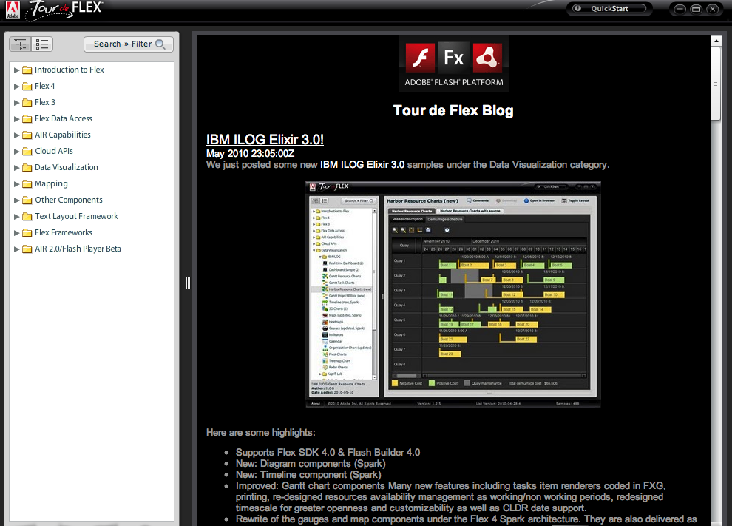
Figure 5 Tour de Flex application

Microsoft Silverlight

In terms of Silverlight, it really was hard to find a complete learning material to learn the framework in detail. I started off using the learning materials on the official Silverlight website, but it wasn’t done it a structured manner. However, luckily I found out that one of the University of Auckland courses was teaching Silverlight programming from scratch—INFOSYS320. Thus, I took some of that course’s material off someone who was taking that course, and started learning Silverlight in detail from the beginning again.
3 Conclusion
Over the course of the first semester, I have done research and doing development work in both RIA frameworks. The areas include the RIA development tools, data binding, UI controls, architecture, and frameworks. At this stage, I felt that both RIA frameworks have a lot in similarity, and it is not clear yet, which is the better RIA framework.
3.1 Future work
As the second half of the project, I will continue to look into the differences between the two RIA languages—Flex and Silverlight. But the focus will be to put together a detailed and complete documentation on how to port from Flex to Silverlight.

Another focus in the second half of the project is to look in the technical differences in the two RIA frameworks. This will essentially be the academic section of the project. The areas that I will likely be looking into are the performance, portability, and usability of the two RIA frameworks.

From what I have researched and read, Blend is one of the best RIA development tools in terms of designs and constructing RIA applications. So, it will be definitely one of my goals for the second half of the project to look into this tool and provide documentations on this tool.

If time allows, I intend to implement a tool that will have an auto code-generator feature, which will read in a set of Flex source code and produce some fundamental equivalent Silverlight code. However, the completeness and correctness of the code generator will largely depend on the research that I have done and will be continue to do. Thus, it is essential for me to do the research part of the project right.
References
1. Moses, J.J Where the Wild Things Are: an Adventure in Silverlight (Act I). InsideRIA (2010)
2. "Web Browser Plugin Market Share". StatOwl. http://statowl.com/plugin_overview.php. Retrieved 2009-08-18.

