Hong Kong Travel 2008

Accommodation:

Ramada Hong Kong Hotel (华美达香港酒店)
308 Des Voeux Road West, Hong Kong (香港德辅道西308号)
Tel: (852) 34103333
Email: hotel@ramadahongkong.com

香港华美达酒店位处港岛西环海旁，维多利亚港之景色尽在眼前，毗邻为穿梭港、澳之渡轮码头，集合商业、娱乐及购物中心之中环亦近在咫尺。
酒店位置优越，往来香港国际机场，迪士尼乐园主题公园及邻近之亚洲国际博览馆十分方便；酒店门前即可乘搭具百年历史之香港电车，直达中环、湾仔、铜锣湾及港岛东各个角落。
酒店共提供307间豪华舒适之客房及套间，每客房及套间均配置铺砌上高格调大理石之浴室，大部分房间尽览维港景色，实为世界各地旅客留港居停之理想地点
Transportation
Hong Kong International Airport > Airport Express Hong Kong Station
(Airport Express / 35 minutes / Adult : HK$100)
Airport Express Hong Kong Station > Hotel (Taxi / 10 minutes / HK$30)

Schedule Summary

Day 1 Highlights

The Peak(山顶), Madame Tussauds(蜡像馆), Lam Kwai Fong(兰桂坊), SoHo(苏豪)，Escalator(电梯)

Day 2 Highlights

Sheung Wan (上环)，Man Mo Temple (文武庙)，Dukling Experience(鸭灵号海上体验), Wishing Tree(林村许愿树), Sha Tin Racecourse(沙田跑马场), Tsang Tai Uk (曾大屋), Symphony of the Lights(幻彩咏香江), Avenue of the Stars(星光大道)

Day 3 Highlights

Bank of China Tower(中国银行), Tsing Ma Bridge(青马大桥), Ngong Ping 360 (昂平缆车), Big Buddha(山顶大佛), Tsim Sha Tsui(尖沙嘴), Nathan Rd(弥敦道), Mong Kok Street Markets(旺角夜市)

Day 4 Highlights

Macau Historical District(澳门历史区), Fisherman's Wharf(渔人码头主题乐园), Macau Tower(澳门旅游塔), Gambling in Macau(澳门赌场)

Day 5 Highlights

Statues Square(皇后像广场), Central (中环)，Hong Kong Convention and Exhibiton Centre(香港会议展览中心), Wan Chai(湾仔)，Causeway Bay (铜锣湾)
Day 1. Friday

Afternoon: Arrival

1． Airport Express (机场特快 $HK100pp.)
出机场, 乘坐 Airport Express to Hong Kong Station ($HK 100 pp.)

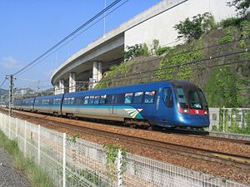
Airport Express is a dedicated airport railway providing fast and reliable service to the passengers. The operating hours are 0550 to 0115 daily. (last train departs from Airport and Hong Kong Stations at 0048 hour) Trains run at 12-minute intervals. The journey time between Airport and downtown is about 24 minutes.
Passenger can take Airport Express from Airport to Tsing Yi Station and interchange Tung Chung Line to Sunny Bay Station to take the Disneyland Resort Line to gain access to Hong Kong Disneyland.
Free services of In-town Check-in* and scheduled shuttle bus are available at Hong Kong and Kowloon stations for Airport Express passengers. Passengers can check-in and collect their boarding passes from one day in advance up to 90 minutes before take-off. They can take the shuttle bus to and from major hotels plus key transport interchanges at these stations . Furthermore, free porter service is available at all Airport Express stations to help carry Airport Express passengers' luggage.
乘坐出租车去酒店 (Taxicab $HK 30 pp.)

2. The Peak (山顶)
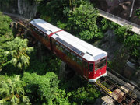
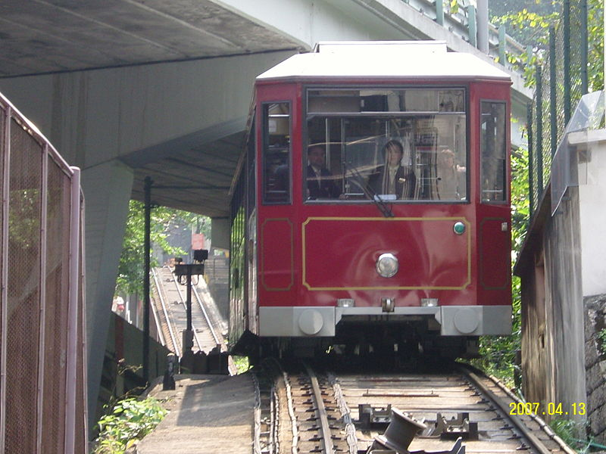

2.1 Peak Tram (山顶缆车）（Peak Tram+Peak Tower $HK37 pp)

乘出租车去Peak Tram Station, 坐the Peak Tram 去the Peak
The Peak Tramway (山顶缆车) is a funicular railway in Hong Kong, which carries both tourists and residents to the upper levels of Hong Kong Island. Running from Central district to Victoria Peak via the Mid-Levels, it provides the most direct route and offers good views over the harbour and skyscrapers of Hong Kong.
The Peak Tram is owned and operated by the Hongkong and Shanghai Hotels group (HSH), the owner of Hong Kong's famous Peninsula Hotel along with many other properties. The line, along with HSH's Peak Tower leisure complex at the line's summit, is promoted using the brand The Peak.
The Peak Tram was opened for public service on May 28, 1888 by the then Governor Sir George William des Voeux.

2.2 The Peak (太平山顶)
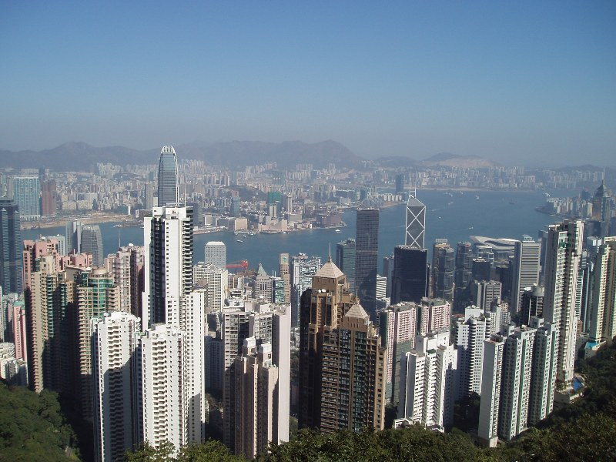
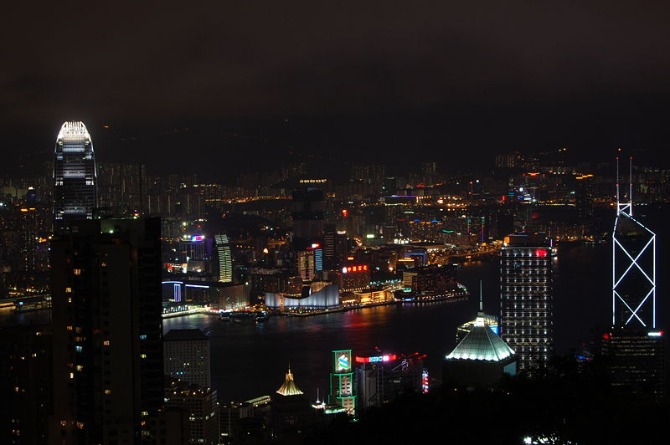
Victoria Peak (traditional Chinese: 太平山頂) is a mountain in Hong Kong. It is also documented as The Peak locally, and Mount Austin. The mountain is located in the western half of the Hong Kong Island. With an altitude of 552 m, it is the highest mountain on the island, although far from the highest Tai Mo Shan in the territory. It is also is known to have the highest land value in the world, with many of the Super-Rich residing here. Because of its view, history and spectacular location Victoria Peak is strongly attached with an air of prestige.

2.3 Lugard Road (卢吉道) 环山行走，观赏西洋美景
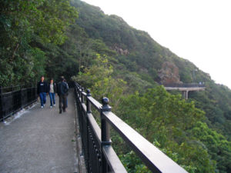
Lugard Road (traditional Chinese: 盧吉道; simplified Chinese: 卢吉道; Pinyin: Lújí Dào; Cantonese Yale: lou4 gat1 dou6) is one of Hong Kong's most splendid walks. It has been a prime walking spot for generations. The road is semi-circular and links with Harlech Road to surround the Victoria Peak. It is a very popular walking path because of its view, tranquility and because it is completely impossible to get lost; just keep on walking and eventually you'll get back to the Peak Tram station. Recent shotcreting efforts have blighted some once pleasant sections, but for the most part the views are still stunning in every direction.
Too narrow in most places to really be a road, for much of its length Lugard Road is more like a path winding past stands of wild banana, fragrant flowering creepers and all sorts of tropical vegetation. Densely shaded for most of its length, Lugard Road enjoys stunning vistas of the harbor, distant islands and densely packed city beneath. This is a place to come to when you need to put the jostling crowds and packed streets below into their proper context. As seen from here, most of the surrounding countryside is made up of extensive green hills with few buildings, an aspect of Hong Kong Island all too easily forgotten a couple of hundred meters further below.
While there are a number of houses at various points along its length, Lugard Road — perhaps surprisingly given its majestic harbour and island views — is not one of the Peak's more sought-after residential addresses. The road is too narrow for cars to pass in most places, the cliffsides for much of its length are too steep to build anything on, and the houses scattered along its length are often considered remote and difficult to access.

2.4 The Peak Tower (山顶凌霄阁)
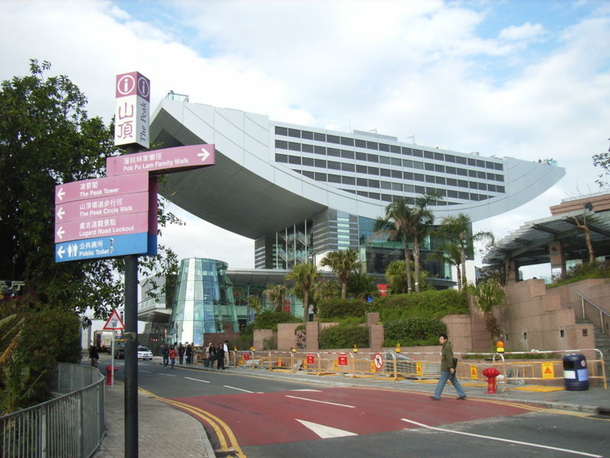
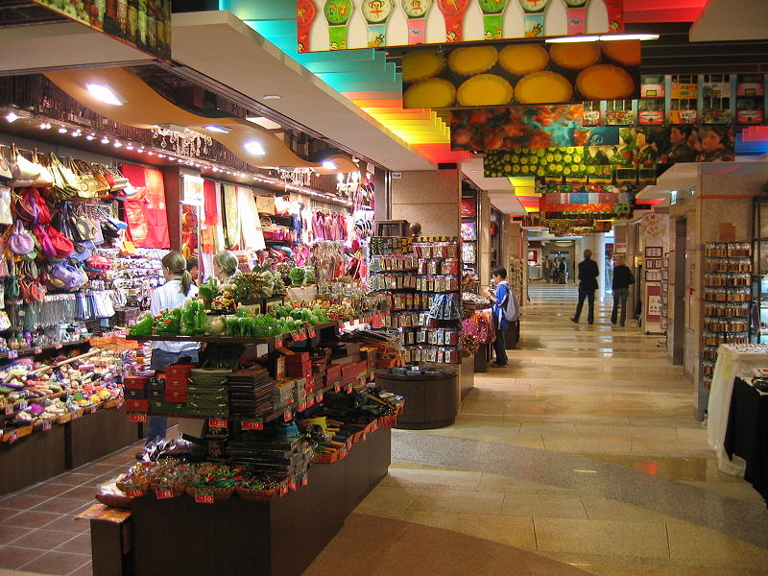
The Peak Tower is a leisure and shopping complex located near the summit of Victoria Peak on Hong Kong Island, Hong Kong. It also houses the upper terminal of the Peak Tram. Both the Peak Tower and the Peak Tram are owned by the Hongkong and Shanghai Hotels group, the owner of Hong Kong's famous Peninsula Hotel along with many other properties. The tower and tram are joinly promoted by the collective branding known as The Peak.
The Peak Tower is located at an elevation of 396 m, 156 m below the summit of Victoria Peak. Because the architects sought a design which would be prominent on the skyline but would not interrupt the natural line of the hills, they chose a site in a dip along the line of the hills, and restricted the tower's height to 428 m above sea level.

2.5 Madame Tussauds (杜莎蜡像馆）

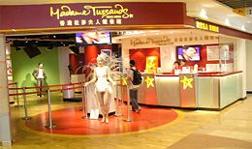
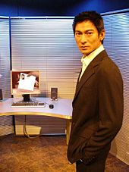
Madame Tussauds Hong Kong, part of the renowned chain of wax museums founded by Marie Tussaud of France, is located at the Peak Tower on Hong Kong Island in Hong Kong. It is the first and one of the only two permanent Madame Tussauds museums in Asia, the other being the Shanghai branch, which opened in 2006. The Hong Kong branch houses nearly 100 wax figures of internationally-known personalities and local celebrities.
位于山顶凌霄阁的香港杜莎夫人蜡像馆，耗资港币2,000万元进行主要扩建工程后，现已换上全新面貌，为参观者带来更多视听效果和互动新体验！这座世界知名的蜡像馆占地三层，共设五个主题展区，展出100多尊栩栩如生的国际和本地名人蜡像，红星巨贾、天才猛将济济一堂，星光熠熠，为您呈献一趟精彩难忘的巨星之旅！
漫游「魅力香江」、「乐坛巨星」、「风云人物」、「世界首映」和「体坛猛将」五个主题展区，不但可与心爱的偶像「会面」和合照，还可亲身参与他们的拿手好戏，如跟高球巨星活士比试身手、与篮球名将姚明一起灌篮入樽、和舞台王者郭富城比拼舞艺，甚至走入伦勃朗的名画之中，化身成为画中的主人翁！
您亦可与世界历史及政治人物并肩而立，体会那种领导群雄的威风感，例如：与中国国家主席胡锦涛一起踏出其专机机舱，接受群众的热烈欢呼；在联合国会场接受美国总统乔治．布殊的委任，并在公众前致辞。
除此之外，您可以在馆内认识蜡像的制造过程，以及在礼品店选购一系列精美的纪念品！
有关详情，请浏览http://www.madame-tussauds.com.hk/chi/index.html。
开放时间：每日上午10:00至晚上10:00
票价：2006年价目平日$HK115周末及公众假期$HK120
购票查询请致电+85228496966。

Other Interesting Places: The Peak Galleria, The worlds most expensive house

Night: Party

3. Central / Mid-Level 中区/半山

3.1 Lan Kwai Fong (兰桂坊）
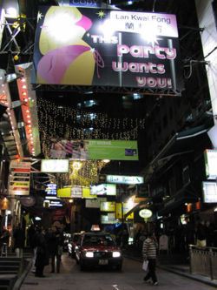
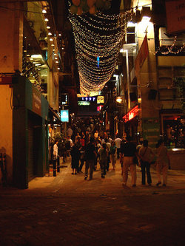
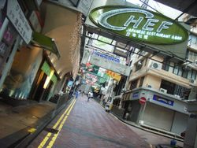
Lan Kwai Fong (traditional Chinese: 蘭桂坊; simplified Chinese: 兰桂坊; Pinyin: Lánguì Fāng; Cantonese Yale: laan4 gwai3 fong1) is a small square of streets in Central, Central and Western district, Hong Kong. The area was dedicated to hawkers before the Second World War, but underwent a renaissance in the mid 1980s. It is now a popular expatriate haunt in Hong Kong for drinking, clubbing and dining. The street Lan Kwai Fong is an L-shape with two ends joining with D'Aguilar Street.
Lan Kwai Fong is perhaps Hong Kong's most popular and well known area for a night out. Boasting numerous bars, pubs, clubs and restaurants, it is a popular choice for the well off locals, expatriates and tourists. The high costs associated with the area makes this a relatively high class location, although the quality and reputation of this area is obvious virtually every night. Visiting on a Friday or Saturday night you may be overwhelmed by the enormous crowds that fill the streets (which are closed for several hours to vehicular traffic), with all bars having only standing room. It is interesting to see that, as mentioned, a majority of the crowds are in fact expatriates or international students. It is one of the few places where English is the overwhelmingly predominant language, although many of the Chinese who are there are most likely to be bilingual.

香港最时尚的饮食消闲地点，非中环兰桂坊莫属。香港华洋杂处，居港的外籍人士、时尚男女和年轻专业人士，都爱流连兰桂坊。兰桂坊的范围，其实不单一条街道，亦包括附近的德己立街、和安里和荣华里，合起来共有超过40家餐厅酒吧，供应国际美食，计有法国、越南、美式、中东、意大利等地方菜。
部分餐厅酒吧更采用开放式设计，让客人共聚畅谈，实为吃喝玩乐的好地方。每逢重要节日，例如平安夜和大除夕，这里更吸引中外男女狂欢畅饮，气氛热闹。

3.2 SoHo (苏豪)
The SoHo (Chinese: 荷南; also 蘇豪) district in Hong Kong is an entertainment zone located in Mid-levels and bordering Sheung Wan, within the Central and Western district. The name is derived from its location: South of Hollywood Road, and it arguably extends up to and including Robinson Road.
One of the easiest ways of getting to SoHo is through the Central-Mid-Levels escalator. It is said that the very existence of Soho is attributed to the creation of the escalator system. The area consists of restaurants, bars, nightclubs, the art galleries and antique stores of Staunton Street and Hollywood Road, and residential housing. Hong Kong taxi drivers usually regard "Soho" to mean either Staunton Street or Elgin Street.
For several years the local district council has fought an ongoing battle against local businesses in the area against formal adoption of the name "Soho", preferring instead the descriptive "Hong Kong Theme Restaurant District". The apprehension is that use of the name "Soho" will cause association with the London area of the same name.

Like much of Hong Kong, this district treads a precarious balance between preserving the Chinese and colonial culture that shaped it, and recent modern developments. The escalator is a quintessential symbol of modernity which has encroached on the residential neighbourhood, bringing with it expats and the bars, cafes and boutiques which help cocoon some from Cantonese traditions.
The contrast between the past and present enriches the area and makes for great sightseeing on foot. The newly signposted Sun Yat-sen Historical Trail guides visitors along 16 points of historical interest from The University of Hong Kong to Central, taking in century old steps and leafy residential lanes. Unfortunately, most of the sites from Dr Sun's past have long been razed, replaced by concrete skyscrapers that are characteristic of 21st century Hong Kong. Even the Dr. Sun Yat-sen Museum's grandiose facade off Caine Road is easy to miss, perched as it is upon Castle Road which turns up through Mid-levels, surrounded by modern blocks.
Nowhere is the contrast more apparent than on the northern edge of Soho, on Hollywood Road itself where the brand new multistorey Centre Stage upscale residential complex towers alongside the historic Man Mo Temple.
When following Staunton Street west from the escalator, what was once a single block of conspicuously expat hangouts has migrated beyond. As property developers and entrepreneurs spread their reach into Sheung Wan and Sai Ying Pun, it's not hard to imagine what will become of the old neighbourhood.

搭乘中环至半山自动扶梯至士丹顿街，就是香港一个较新的美食地带－SoHo荷南美食区。些利街、伊利近街、卑利街、士丹顿街及奥卑利街一带的小街道，聚集了不少别具异国风情的特色餐厅、咖啡室及酒吧。
3.3 Escalator (电梯)
The "Mid-Levels Escalators" are a series of escalators going from Des Voeux Road in Central up to Conduit Road of the Mid-Levels (the mid section of the hill on Hong Kong Island). It just goes up and up and up!
Along the way, there are restaurants and shops, especially in the lower sections.
It takes about 20-25 minutes to take the escalators all the way up to Conduit Road.
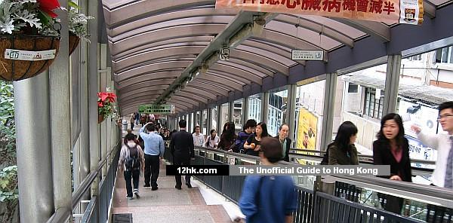
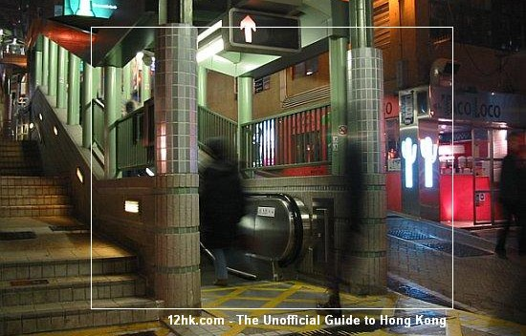
Directions:
Here are the directions to get to the bottom of it to go up.
1. Go to the Central station of the MTR (subway train)
2. Take exit C
3. Once you are on street level (Des Voeux Rd Central), turn left (going northwest).
4. After 3 or 4 blocks, you will see Hang Seng Bank Headquarters building on your right (tall building with big rounded metalic corners), and Central Market (slated to be demolished some time) on your left (sandwiched between Queen Victoria Street and Jubilee Street). You will also see two pedestrian bridges / skywalks in between overlooking Des Voeux Rd Central. Go up to the same level as the pedestrian bridges.
5. Go southwest once you are upstairs along side the Central Market (away from Des Voeux Rd Central).
6. At the other end of that building, you will find the connection to the escalators.

还记得在电影《重庆森林》中，女主角王菲从公寓的窗口，窥视心仪的警官梁朝伟，搭乘着电动楼梯上班模样那一幕吗？您也许会觉得不可思义，怎会在如此邻近公寓的地方有手扶梯呢？事实上那是专门为住在山上的居民所建造的手扶梯，也是目前世界上最长的电动扶梯。以直扶而上的电动楼梯替代弯弯曲曲的山路，可算是香港人的奇想妙招吧。电动楼梯的起点在皇后大道中的中央街市场，沿阁麟街而行，在荷李活道，再接着些利街、干德道，进入半山区，高低的落差有135公尺之多，将中环的旧式房子和半山的高级区结合在一起。沿途的风光变化很有意思，可以看到繁华的商业街，然后经过旧公寓群阳台吊着纷乱衣物的景象，最后抵达有着宽广大厅的高级别墅。全程约20分钟让您窥得香港平民化和繁华都会的不同生活面貌。重点是这趟旅程完全免费。

Day 2. Saturday

Morning:

1. Sheung Wan (上环游)

1.1 Hollywood Road (荷里活道)
Hollywood Road is a road in Central, Hong Kong, China.
Hollywood Road is renowned for its presence in various Hollywood movies, the first pictures of Hong Kong available to an international audience.
Hollywood Road is filled with trinket and antique shops of all sorts: from Chinese furniture to porcelain ware, from Buddha sculptures to Tibetan rugs, from Japanese netsukes to Coromandel screens, from Ming dynasty ceramic horsemen and kitsch Maoist memorabilia. The street runs between Central and Sheung Wan, with Wyndham Street, Arbuthnot Road, Ladder Street, Upper Lascar Row, and Old Bailey Street in the vicinity.
Hollywood Road was the second road to be built when the colony of Hong Kong was founded, after Queen's Road Central. It was the first to be completed. The Man Mo Temple was a place for trial in very early years.
荷李活道虽以Hollywood为名，却与美国电影重镇无关，唯一相同之处是两地均是热门旅游点。荷李活道以成行成市的古董商店著称，货色应有尽有，无论是中式酸枝家具、挂墙书画卷轴、陶瓷或各类小古玩，种类齐全，价格不一，喜爱四处搜罗珍品的旅客在这里必然大有所获。
摩罗上街及乐古道昔日多海员聚居，附近妓院林立，龙蛇混杂，但现在已衍变成古董和杂货市场。距乐古道不远的摩罗街中心，正门有两头唐代石狮（乃按照北京北海公园九龙壁的实物仿造），是售卖东方美术品、手工艺品和古董文物的集中地。

1.2 Man Mo Temple (文武庙)

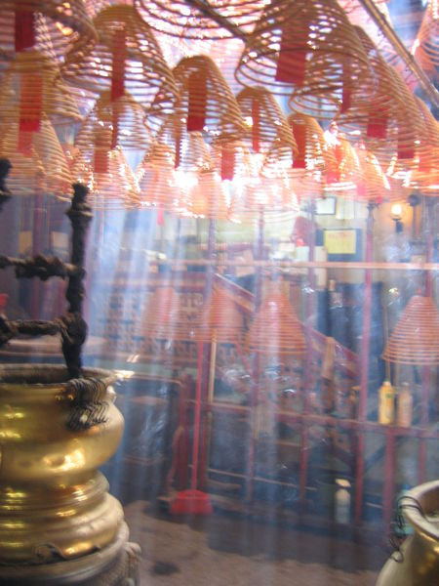
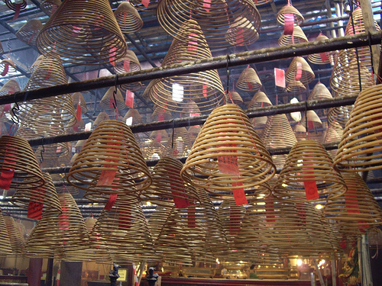
Man Mo Temple or Man Mo Miu (traditional Chinese: 文武廟) is a temple in Hong Kong, China, that reveres the God of Literature, Man Tai (文帝), Man Cheong （文昌） and the God of War, and Mo Tai (武帝) or Kuan Ti, Kwan Yu（關羽). It was built after two gods, Man the god of literature and Mo the god of war.
The temple itself also made an appearance in the video game Shenmue II for the Dreamcast and Xbox consoles. You can explore the temple and its grounds, however its locale is different to where it is in real life.
The one on Hollywood Road, Sheung Wan was built in 1847. It has been managed by Tung Wah Group of Hospitals since 1908. It is one of Grade I historic buildings in the District.
The one in Tai Po has been listed as a declared monument of Hong Kong.
The Man Mo temple is open from 8:00am to 6:00pm daily.
文武庙位於荷李活道和楼梯街交界，供奉一文一武的两位神祇：「文」昌帝（手执毛笔者）职司文学和官禄，关「武」帝（身穿绿长袍，身持长剑者）代表忠义武略。庙内的布置，极富传统中国庙宇的特色：有精铸的铜和白蜡香炉鼎，还有雕工精细的神像木座。从前举行地方巡游时，村民会把神像安放在这些木座上。此外，庙内挂着大型的塔香，回旋向上，可以燃烧整整三个星期。这种长燃不熄的香代表祈求健康、财富和快乐的祝愿。

1.3 Western Market (西港城)
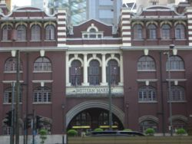
Western Market is one of the oldest structures in Sheung Wan, Hong Kong Island, Hong Kong. It is also the oldest surviving market building in the city. On the Edwardian style structure, the brickwork on the 4 corner towers is bandaged.
西港城（Western Market）是一座商場，位於香港上環德輔道中323號。
西港城的前身是舊上環街市北座大樓，大樓建於1906年，採用英國愛德華式建築風格，以紅磚砌成，花崗石作地基，底層入口有大型圓拱，具有歷史價值。大樓最初是船政署總部舊址，後來才改建為街市。1983年上半年，街市南座因興建地下鐵路港島綫第二期建築工程而遷出，原址興建上環市政大廈。街市北座而1989年1月起空置。
在1990年，它被港英政府的古物古蹟辦事處列為香港法定古蹟。1991年，由土地發展公司（今市區重建局）把大樓進行全面修葺，並改建成具有香港文化特色的傳統行業及工藝品中心。在2003年由市區重建局再進行活化工程，增添主題餐廳及幾家特色商店。[1]
場內部分商舖原為附近一帶的老字號，當中包括古玩與特色手工藝品店等。2樓的布匹專賣店，皆從已遷拆的花布街(中環中心現址)搬遷至西港城。
西港城原本有上下2層，在修葺後加建了2層，成為共4層的建築，頂層開設了懷舊舞酒樓。

Other Interesting Places: Bonham Strand West (文咸西街) Wing Lok St. (永乐街)参茸燕窝街
Des Voeus Rd. West (德辅道西) 海味街

2. Duk Ling Experience (鸭灵号海上体验)
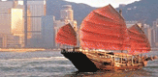
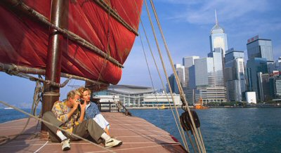

登上中式帆船，畅游维多利亚港，360度尽览香港大都会景色，感受至深！「鸭灵号」原为中国渔民所拥有，是一艘典型的中式帆船，150年前，纵横香港水域的就是这种帆船。现在，您们可以登上「鸭灵号」，缅怀昔日洋行大班与商家云集的传奇岁月，一发思古之情。这艘帆船在海上航行超过25年，于1980年代经过修复，保存了原有的经典外观。

登船： 九龙：星期四下午2:00及4:00；星期六上午10:00及中午12:00
尖沙咀九龙公众码头
(地铁尖沙咀站E出口，步行至梳士巴利道后右转，取道香港基督教青年会旁的人行隧道前往香港文化中心，然后
往右步向海旁。九龙公众码头位于天星码头左方。)
香港岛：星期四下午3:00及5:00；星期六上午11:00及下午1:00；
中环九号码头(公众码头)
(地铁香港站A2出口，沿民耀街的有盖行人路向海傍步行10分钟。)
报名： 香港旅游发展局旅客谘询及服务中心
全程： 约1小时
费用： 免费
每程名额： 30人
网站： www.dukling.com.hk
查询： 香港旅游发展局旅游热线+852 2508 1234
旅客必须亲自前往旅客谘询及服务中心预先报名。
航行时或有风浪，建议旅客预先采取适当准备。
建议参加者年龄为3至75岁。
是项活动由香港旅游发展局主办。

Afternoon: Sha Tin

4. Wishing Tree (林村许愿树)
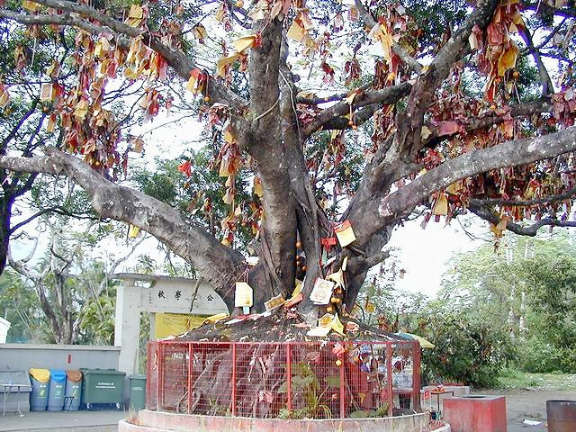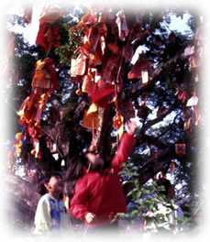
The Wishing Tree, located near the Tin Hou Temple in Lam Tsuen, is one of Hong Kong's most famous tourist attractions. It is usually crowded during the Chinese New Year holidays and seems to be covered in deep crimson colors whenever seen from a distance. Only up close, do you realize that the Wishing Tree is actually laden with wishes written on bright red paper.
The Spirit Tree used to be a camphor tree where a tablet for enshrining and worshipping Pak Kung was placed. As time went on, the branches and leaves began to wither and eventually it became a hollow tree. A villager told us that once there was a worshipper who had a son very slow in learning. As a result of the wish he made after worshipping the hollow tree, his son completely changed and made incredible improvements in his academic performance. Word spread and people flocked this Tree to make wishes. The Tree is said to be quite generous with its magic. Today, it not only attracts people from all around Hong Kong, but it is also popular with foreign visitors. It has become one of the biggest tourist attractions of Hong Kong.
Chinese people are superstitious. They trusted that there are gods who could bless them. Gods would also help them to achieve their wishes. As one of the means to worship the gods, they write their wishes and throw them onto the Wishing Tree.
Transportation：
The transportation facilities there are adequate - you can take buses or minibus to get there. After you arrive at the Taipo Market train station, you can take the buses 64K or 65K, or the minibus 25K. Of course, those who are willing to pay more, can take a taxi.

林村天后廟外有兩株老樹，本地人名之許願樹。許願樹原是一棵大榕樹，樹下立有伯公神位，由於年代久遠，枝幹日漸枯萎，遂成為通心樹。據傳有一善信，其子入學毫無寸進，經拜通心樹後智慧頓開，學業有成。其後，許願樹的聲名不脛而走，善信絡繹不絕，特別在農曆新年，這裡更成為善信祈福許願的熱門地點。
於港鐵大埔墟站乘64K線巴士，在放馬莆(林村許願樹)巴士站下車。

5. Sha Tin （沙田区）

5.1 Ten Thousand Buddhas Monastery （千佛寺）
Ten Thousand Buddhas Monastery is a Buddhist temple in Shatin. It is located at 220 Pai Tau Village, Shatin.
要攀上此寺所在的山顶首先必须登431个石阶。之所以称此寺为「万佛寺」，是因为自1950年代建寺以来，感恩的信众便不断供奉小神像，使得它成为一座拥有10,000尊佛像的寺庙。这些神像各个不同，有些是黑色的、有些则盖以金箔，而且每尊神像的姿态各异，这象征着佛祖修成正果的各个不同阶段和过程。
寺内尚有玉皇殿、准提殿、弥陀殿、万佛宝塔及十八罗汉塑像等。可惜，万佛寺在九七年七月的一场暴雨中倒塌，有关方面现正着手筹募经费重建佛寺，希望能够尽快令万佛寺重现昔日的光辉。从中庭的边缘可以俯瞰沙田美妙的景致，中庭里有座九层的佛塔和一些佛祖追随者的雕像。再往上走则是另外四座寺庙，其中一个拥有全香港第二高的佛像.供奉的该寺创始和尚月溪法师肉身漆像，是香港仅有的一座。
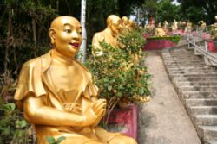
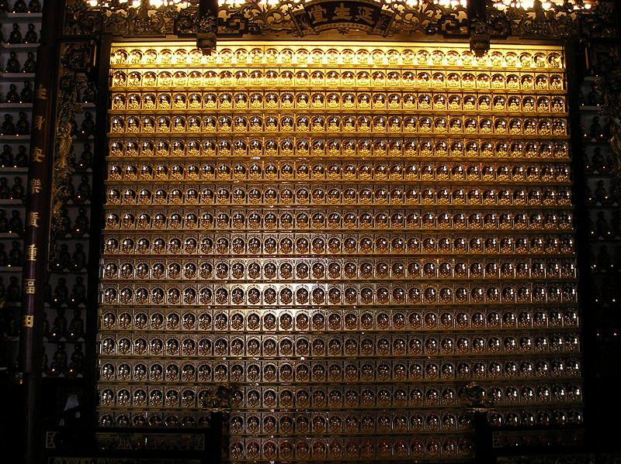
5.2 Tsang Tai Uk (曾大屋)
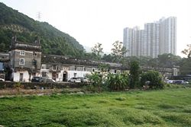
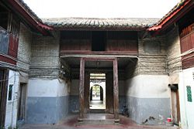
Tsang Tai Uk also known as Shan Ha Wai, is another well-known Hakka walled village in Hong Kong, and one of the best preserved. It is located close to the south of the Pok Hong Estate, not far from the Lion Rock Tunnel Road. Built in the 1840s, it was constructed in 1848 as a stronghold for the Tsang Clan. It is a preserved Hakka fortified village in Sha Tin. It is said to have taken 20 years to build the village. The village is built with granite, grey bricks and solid timber.
The founder of Tsang Tai Uk is Mr. Tsang Koon Maan, he is a wealthy man. He has a shop and he sells water to earn money. Tsang Tai Uk is rectangular in shape and consists of 3 rows of houses which are surrounded by grey-brick compound with high, thick walls and tall corner towers. All the houses are interlinked by passages and small courtyards. On the fortified walls,there are embrasures and loopholes. At the four corners, defensive towers were built to ward off enemies in the old days.
Ceremonies take place in the ancestral hall in the innermost row of houses. There are 3 arched entrances at the northern wall. The main or the ceremonial entrance is in the middle and leads to the ancestral hall.
In front of the house is a massive courtyard, where in the old days, villagers winnowed and dried their harvest.
Originally designed as the home for a rich quarry-master's clan, the walled village gained its current name when it gave refuge to displaced families after the Second World War. It is one of Grade I historic buildings as at 6 January 2007.
Route: Ma On Shan Line to Che Kung Temple or Sha Tin Wai and walk to Tsang Tai Uk

5.3 Sha Tin Racecourse （沙田马场）
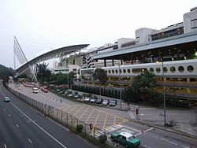
於1978年启用的沙田马场，是全球设备最完善的马场之一，可容纳83,000名观众。在每年9月至翌年7月初马季期间，沙田马场每星期都会举行赛事，一般在星期叁晚上或星期六/日的下午举行。
旅客如年满18岁，同时，在港停留不超过21日，便可购买入场证进入跑道旁的会员席观赏赛事；又或参加赛马观光团，把一切观赛安排交予专人代劳。
场内设有全球最阔的彩色大屏幕，长70.4米，面积相等於4,500部架叠起来的52厘米电视机，详尽显示每一场赛事的资料及赛果。此外，还设有投注站，欢迎旅客一试运气，说不定会有意想不到的收获呢！

5.4 New Town Plaza （新城市广场）
New Town Plaza is a shopping mall in the town centre of Sha Tin in Hong Kong. Developed by Sun Hung Kai Properties, it was the biggest shopping mall in the New Territories of Hong Kong when it was completed in the early 1980s. Covering 200,000 square metres (49.4 acres), the plaza comprises Phase 1 (the main mall), Phase 3, which are connected to each other, and Grand Central Plaza, which is less than one kilometre from Phase 1. Currently under extensive renovation, the nine-storey main mall is right next to Sha Tin station and Citylink Plaza.

Night: Tsim Sha Tsui (夜游尖沙嘴)

6. A Symphony of Lights Harbour Cruise （幻彩咏香江）
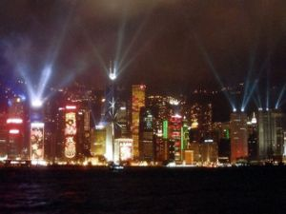
A Symphony of Lights ( Traditional Chinese: 幻彩詠香江) is a synchronised building exterior decorative light and laser multimedia display, featuring 44 buildings on both sides of the Victoria Harbour of Hong Kong accompanied by symphonic music. The technology was developed by Australian firm Laservision and cost approximately 44 million HK dollars. It has attracted over 4 million visitors and locals so far.
Guinness World Records has named A Symphony of Lights the world's largest permanent light and sound show.
Organised by the Hong Kong Tourism Board. Displayed every night with good weather at 8pm Hong Kong Time, the show is an orchestration of music, decoration lights, laser light displays, and pyrotechnic fireworks. The multimedia light and sound show lasts for about 14 minutes.
The best vantage points include the "Avenue of Stars" on the Tsim Sha Tsui waterfront, on the waterfront promenade outside the Golden Bauhinia Square in Wan Chai and on sightseeing ferries (i.e. Star Ferry) running across the Victoria Harbor. The Show's music and narration live at the "Avenue of Stars" and the promenade outside the Golden Bauhinia Square in Wan Chai every night. On Mondays, Wednesdays and Fridays the narration is in English, while it is in Mandarin on Tuesdays, Thursdays and Saturdays, and Cantonese on Sundays.
Special pyrotechnic fireworks will be added to the show on the rooftop of participating buildings on both sides of the habour or stages off at the Tsim Sha Tsui waterfront. It will be added on special events or holidays, example like Chinese New Year and Christmas.
When Tropical Cyclone Warning Signal No.3 or above or Red/Black Rainstorm Warning Signal is issued by the Hong Kong Observatory at or after 3pm on the Show day, the Show will be suspended. No show will be staged even if the Signal is removed before 8pm on that day. The show may also be suspended in emergencies without prior notice.

幻彩咏香江已被列入《吉尼斯世界纪录》，成为全球最 大 型 灯 光 音 乐 汇 演。每晚8:00 ，维多利亚港两岸的33 幢建筑物即变身成为声光交织的表演舞台，缤纷跳跃的灯光 、充满节奏感 的音乐以及旁白互相配合 ， 令香港的夜景更加璀璨耀目。
全新制作的汇演共有五个主题，先以「旭日初升」作序幕，然后是「活力澎湃」、「继往开来」和「共创辉煌」，最后以「普天同庆」为压轴。在特别日子，汇演还会加插海上烟火表演。观众可前往以下观赏地点*，以最佳角度欣赏「幻彩咏香江」。此节目由旅游事务署倾力呈献。
日期：每晚
时间：晚上8:00
观赏地点：
1.尖沙咀海滨花园的「星光大道」(现场设配乐广播)
2.湾仔金紫荆广场海滨长廊(现场设配乐广播)
3.参加海上观光团，登上特备专船，于维多利亚港内欣赏表演**
查询：+85225081234
网址：http://www.tourism.gov.hk/symphony
备注：观众可于「星光大道」及湾仔金紫荆广场海滨长廊收听音乐和旁述的现场广播，逢星期二、四、六以国语播送，星期日则以广东话播送。此外，观众每晚亦可在维港海旁透过电台频道FM106.8(广东话)或FM107.9(国语)收听；或用手机拨号35665668(国语)收听；手机网络供应商将按一般电话时间收费。
#如香港天文台于汇演当日下午3:00或以后，发出三号或以上热带气旋警告讯号或红色/黑色暴雨警告讯号，则当晚之汇演将会暂停；即使该警告讯号于当日晚上8:00前除下，是晚汇演亦会暂停举行。此外，汇演亦可能因紧急事故而需暂停，恕不另行通知。

8．Tsim Sha Tsui (尖沙嘴)

8.1 Avenues of the Stars (星光大道)
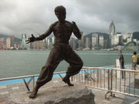
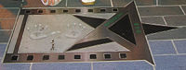
The Avenue of Stars is the eastern node of several tourist attractions along the Tsim Sha Tsui waterfront. In addition to the promenade and New World Centre, a number of attractions exist including the Museum of Art, Space Museum, Cultural Centre and the Clock Tower.
Entering from Salisbury Garden, a 4.5-metre-tall replica of the statuette given to winners at the Hong Kong Film Awards greets visitors. Along the 440 metre promenade, the story of Hong Kong's one hundred years of cinematic history is told through inscriptions printed on nine red pillars. Set into the promenade are plaques honouring the celebrities. Some plaques contain hand prints and autographs of the stars set in cement, but most of the plaques only contain celebrities' names as they are now deceased.
The promenade commands a stunning panoramic view across Victoria Harbour. At night it is a popular viewing place for the Symphony of Lights display. It is a good place to go to to see the glamourous stars of HK.

8.2 Harbour City （海港城购物中心）

8.3 New World Centre (新世界中心)
Day 3. Sunday

Morning:

1. Bank of China Tower (中银大厦)
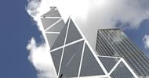
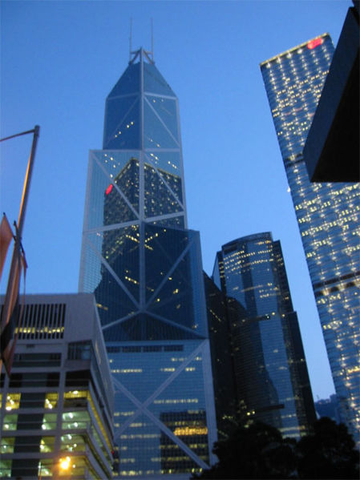
The Bank of China Tower (abbreviated BOC Tower; traditional Chinese: 中銀大廈) is one of the most recognized skyscrapers in Central, Hong Kong. It houses the headquarters for the Bank of China (Hong Kong) Limited. The building is located at 1 Garden Road, in Central and Western District on Hong Kong Island.

Designed by I. M. Pei, the building is 305 m (1,000.7 ft) high with two masts reaching 367.4 m (1,205.4 ft) high. It was the tallest building in Hong Kong and Asia from 1989 to 1992, and it was the first building outside the United States to break the 305 m (1,000 ft) mark. It is now the third tallest skyscraper in Hong Kong, after Two International Finance Centre and Central Plaza.

Designed by Pritzker Prize-winning architect I. M. Pei, the building is 305.0 metres (1,000.7 ft) high with two masts reaching 367.4 metres (1,205.4 ft) high. The 72 story building is located near Central MTR station. This was the tallest building in Hong Kong and Asia from 1989 to 1992, the first building outside the United States to break the 305 m (1,000 ft) mark, and the first composite space frame high-rise building. That also means it was the tallest outside America from its completion year, 1990. It is now the third tallest skyscraper in Hong Kong, after Two International Finance Center and Central Plaza.

A small observation deck on the 43rd floor of the building is open to the public; visits to the main observation deck on the 70th floor are by appointment only.
The structural expressionism adopted in the design of this building resembles growing bamboo shoots, symbolising livelihood and prosperity. The whole structure is supported by the five steel columns at the corners of the building, with the triangular frameworks transferring the weight of the structure onto these five columns. It is covered with glass curtain walls. While its distinctive look makes it one of Hong Kong's most identifiable landmarks today, it was the source of some controversy at one time, as the bank is the only major building in Hong Kong to have bypassed the convention of consulting with feng shui masters on matters of design prior to construction.
The building has been criticised by some practitioners of Feng Shui for its sharp edges and its negative symbolism by the numerous 'X' shapes in its original design, though Pei modified the design to some degree before construction following this feedback. The building's profile from some angles resembles that of a meat cleaver. In Feng Shui, this is described as a cleaver building and it is not difficult to observe that it is facing the HSBC Hong Kong headquarters building in this guise.

2. Tsing Ma Bridge (青马大桥)
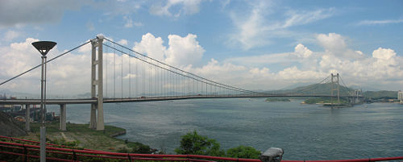

Tsing Ma Bridge is a bridge in Hong Kong, China. It is the world's sixth largest suspension bridge. The bridge was named after two of the islands in Hong Kong, namely Tsing Yi and Ma Wan . It has two decks and carries both road and rail traffic, which also makes it the largest suspension bridge of this type. The upper deck carries a dual three-lane carriageway and there are two tracks of railway and a two-lane emergency roadway in the lower deck for maintenance and the diversion of traffic during high winds. It has a main span of 1,377 metres (4,518 ft) (more than the famous Golden Gate Bridge in San Francisco) and a height of 206 metres (676 ft). The span is the largest of all bridges in the world carrying rail traffic.

The 41 metres (135 ft) wide bridge deck carries six lanes of automobile traffic, three lanes in each direction. The lower level contains two rail tracks. There are also two sheltered carriageways on the lower deck for maintenance access and as backup for traffic when particularly severe typhoons strike Hong Kong. Though road traffic would need to be closed in that case, trains could still get through in either direction. Along with the Ting Kau Bridge and Kap Shui Mun Bridge, it is closely monitored by the Wind and Structural Health Monitoring System (WASHMS).
The Tsing Ma Bridge links Tsing Yi Island on the east to Ma Wan island on the west over Ma Wan Channel. It is part of the Lantau Link, which, with two long span bridges links the New Territories and Lantau Island, and eventually leads to the Hong Kong International Airport on Chek Lap Kok via North Lantau Highway. The other bridge is the Kap Shui Mun Bridge linking Ma Wan to Lantau Island over Kap Shui Mun. The two bridges are connected over Ma Wan by Ma Wan Viaduct
The rail line is part of MTR's Tung Chung Line and Airport Express.
Surveillance cameras were installed over the bridge to record traffic conditions. The video is available at the government website [1]. It is updated every two minutes.
The Tsing Ma Bridge has been an important gateway to Lantau. It will become part of the planned Route 8 expressway, which will connect the Lantau Link, the West Kowloon expressway, Cheung Sha Wan and Shatin.

Tsing Ma Bridge has become a favourite scenic spot as well as a famous landmark. In order to watch and get further information about it, one can go to the Lantau Link Visitor Centre and Viewing Platform which is located at the northwest corner of Tsing Yi Island, just next to the Bridge's Tsing Yi end. Pictures and the structure of the Lantau Link and Ting Kau Bridge are on display at the Centre. The Visitors Centre is opened from 10:00 am to 5:00 p.m. on weekdays (closed on Wednesday); from 10:00 am to 6:30 p.m. on Saturdays, Sundays and most of the public holidays. From the Scenery Viewing Platform, one can also see the Ting Kau Bridge and Kap Shui Mun Bridge. They are the other two bridges listed in the world's "Three Mosts" as well.
There is no sidewalk on the Bridge. Parking is also prohibited on this gigantic Bridge.

Ways to get there
- To the bridge
There are several ways to travel along the upper deck of the Bridge. The cheapest way is to take a bus running between the Hong Kong International Airport (or Tung Chung or Hong Kong Disneyland Resort as well) and the city. These Citybus and Long Win Bus routes have the route number prefixes "A" and "E".
- To the Visitor Centre and Viewing Platform
Only cars, taxis and private coaches can reach the Visitor Centre. Taxis can be caught at the nearest MTR station, Tsing Yi Station, which cost around HK$30. There are parking places for cars and coaches.

青馬大橋自1997年5月開放通車以來，成為連接大嶼山香港國際機場及市區的幹線公路，不單是香港一個主要的建築標誌，更是全球最長的行車及鐵路吊橋。
青馬大橋自1992年5月起開始興建，1992年造價71.44億港元，歷時五年竣工，橋身長度為2.2公里，主跨長度1,377米，離海面高62米。其混凝土橋塔高206米，採用的吊纜鋼線總長度達16萬公里，單是結構鋼重量便高達五萬公噸。
青馬大橋除創造世界最長同類型吊橋紀錄外，包括青馬大橋在內的「機場核心計劃」還於1999年榮獲美國建築界權威及編輯選為「二十世紀十大建築成就獎」得主之一，與巴拿馬運河、英法海峽隧道及三藩市金門大橋等其他九項工程同享殊榮。
青馬大橋聯同另一條跨海吊橋－汲水門大橋－合組成為青嶼幹線的一部分。本港多個地點均可欣賞到青馬大橋的壯麗景觀，旅客亦可選擇到「青嶼幹線觀景台及訪客中心」，眺望青馬大橋的景致。
1.於港鐵青衣站A1出口乘308M專線小巴往訪客中心
2.於港鐵青衣站A1出口乘計程車前往。
註：所有機場巴士均會途經青馬大橋和汲水門大橋。
3. Lantau Island (大屿山之行)

3.1 Ngong Ping 360 (昂平缆车／市集)
Ngong Ping Village is set on a 1.5 hectare site on Lantau Island, adjacent to Ngong Ping Cable Car Terminal and the Tian Tan Buddha Statue. This amazing cultural themed village has been architecturally designed and landscaped to reflect the cultural and spiritual integrity of the Ngong Ping area. It boasts several major attractions - Walking with Buddha, Monkey's Tale Theatre and the Ngong Ping Tea House - as well as a diverse array of retail, dining and entertainment experiences.
Strolling around the Village, you will be entertained by an ever-changing array of street performances. Watch out for the kung-fu demonstrations, be amused by the impressive talents of our jugglers or just take the time to enjoy a Chinese acrobatic show.
昂坪市集展现了昂坪地区的风俗和文化，邻近昂坪缆车站及天坛大佛，占地1.5公顷，其建筑及园林设计烘托出昂坪独特的文化气息及精神面貌。除了「与佛同行」、「灵猴影院」及「昂坪茶馆」等三大特色景点外，更提供多姿多采消闲、餐饮及购物新体验。
于「昂坪市集」中逛逛，旅客亦可欣赏多采多姿的街头表演节目：功夫、杂耍表演及其它精采特备节目，令人目不暇给，乐而忘返

坐落于大屿山的「昂坪360」，为游人带来启迪身心的旅游新体验。旅客可从香港国际机场附近的东涌搭乘空中缆车登山，轻松到达凝聚中华文化特色的昂坪市集；缆车路线全长5.7公里，沿途景色如画，可全方位欣赏南中国海风光。昂坪市集占地1.5公顷，除了购物及饮食设施之外，还包含「与佛同行」、「灵猴影院」及「昂坪茶馆」三个大型主题景点，让您和家人探索远古文化的轨迹，深深体会那种像走进时光隧道的悸动！

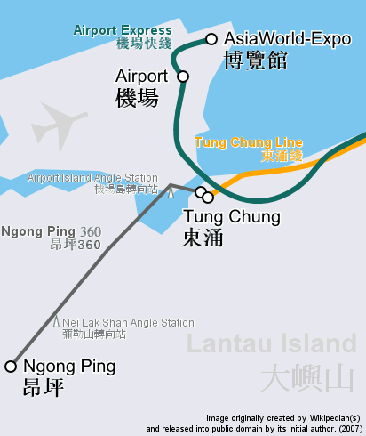
3.2 Ngong Ping 360 Cable Car (昂平缆车) Single Trip: $HK58 pp. Return Trip: $HK88 pp.
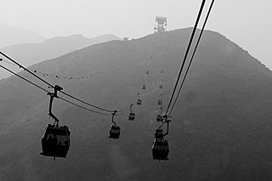

Bus From Ngong Ping to Tung Chung Bus Number 23 $HK 25 pp.

3.3 Big Buddha / Po Lin Monastery (天坛大佛／宝莲禅寺)
The statue is named Tian Tan Buddha because its base is a model of the Altar of Heaven or Earthly Mount of Tian Tan, the Temple of Heaven in Beijing. It is one of the five large Buddha statues in China. The Buddha statue sits peacefully on a lotus throne on top of a three-platform altar. It is surrounded by eight smaller bronze statues representing gods or immortals.

The Buddha is 34 meters high, weighs 250 tonnes, and was the world's tallest outdoor bronze seated Buddha prior to 2007. It can even be seen as far away as Macau on a clear day. Visitors have to climb 268 steps in order to reach the Buddha, though the site also features a small winding road to the Buddha for vehicles to accommodate the physically challenged.
The Tian Tan Buddha appears serene and dignified. His right hand is raised, representing the removal of affliction. His left hand rests on his lap in a gesture of giving (dhana). The Buddha faces north which is unique among the great Buddha statues. (All others face South.)
In addition there are 3 floors at the bottom of Buddha: The Hall of Universe, The Hall of Benevolent Merit and The Hall of Remembrance. One of the most renowned features inside is a relic of Sakyamuni, consisting of some of his alleged cremated remains. There is a huge carved bell inscribed with images of Buddhas in the show room. It was designed to ring every seven minutes, 108 times a day, symbolizing the release of 108 kinds of human vexations.
The Tian Tan Buddha was constructed beginning in 1990, and was finished on December 29, 1993, the birthday of Sakyamuni. The construction costs of the giant Buddha were estimated to be up to $68 million. It was formed out of 202 separate pieces of bronze. In addition to the exterior components, there is a strong steel framework inside the statue to support the heavy load and wind pressure.

When the statue was completed, monks from around the world were invited to the opening ceremony. Distinguished visitors from mainland China, Hong Kong, Taiwan, Japan, Thailand, Korea, Malaysia, Singapore, Sri Lanka, and the United States all took part in the proceedings.
On October 18, 1999 the Hong Kong Post Office issued a stamp depicting the Tian Tan Buddha. The MTR corporation has also issued a tourist souvenir ticket featuring a photograph of the statue.
Time and Price:
Po Lin Monastery and the Buddha are open to the public between 10:00 and 17:45. Access to the Buddha is free of charge. An entrance fee of HK$ 60 is charged for access to the exhibition halls below the Buddha and includes a vegetarian meal (HK$ 100 for the deluxe dinner) served on the monastery grounds (from 11:30 to 17:00). The admission fee includes a souvenir card featuring an image of the Buddha.
Located around the site are various shops selling Buddha-related souvenirs such as statues, incense, and necklaces.
Visitors may also see the nearby monastery, known as the "Buddhist Kingdom in the South," which serves as an international Buddhist retreat, and is one of the largest and most well known in Hong Kong. The monastery was built by three Zen masters in 1920. The main temples have painted vermilion interiors with dragons and many other different Chinese mythical figures on the walls and ceilings. Visitors often spend time in the attached tea garden, the only tea garden in the territory. A five minute walk past the tea garden takes you to the "Wisdom Path" - a very large wooden inscription of the Heart Sutra set within a figure 8 to symbolize infinity. There is a great scenic view of the Tian Tan Buddha if you climb all the way to the top of the hill.
One of the main attractions of this Buddha statue is climbing 268 steps and circling the platform (the lotus) where the Buddha sits.
Also nearby is Lantau Peak, the second highest mountain in Hong Kong, a path up and along which also offers a great view of the Buddha and the monastery.
Transport:
Visitors can reach the site by bus or taxi, travelling first to Mui Wo (also known as "Silvermine Bay") via ferry from the Outlying Islands piers in Central (pier No. 6), or to Tung Chung station via the MTR. Visitors may then travel to and from and Buddha via the following bus routes:
- Mui Wo ↔ Ngong Ping — NLB No. 2
- Tung Chung ↔ Ngong Ping — NLB No. 23 (Buy ticket at booth near bus stop, or pay with exact amount in line. One-way fares (as of Dec 2007): $16 HKD Mon-Sat, $25 HKD Sun/Holidays)
A gondola lift, the Ngong Ping Skyrail between Tung Chung and Ngong Ping, provides another means of access.
宝莲禅寺是大屿山最受欢迎的旅游点，也是香港的佛教圣地，坐落於海拔520米的昂坪平原上，四周风光如画。此寺藏经丰富，供奉得道高僧圆寂后化成的舍利子，亦设有大型斋堂。寺院附近开设有香港唯一的茶园，旅客可在此品尝茶园出产的名茶。在宝莲禅寺留宿一宵的访客，可在大清早起床，到凤凰山观赏日出；凤凰山高934米，是全港第二高峰。

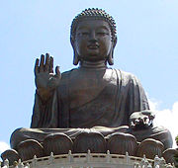
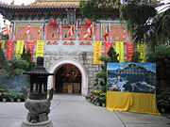
坐落於宝莲禅寺旁的天坛大佛，由中国航天部承包工程，从筹建到建成历时25年，1993年12月开光并开放给公众参观。天坛大佛是全球最高的户外青铜坐佛端坐在叁层祭坛上，高34米，重250公吨，佛祖的面庞由原块青铜铸造，面积达30平方米，宏伟肃穆。游人可攀上268级石阶，参拜大佛，或在平台上远眺大屿山和南中国海的无际风光。
游毕宝莲禅寺，您可搭乘巴士或计程车，前往岛上其他旅游景点，包括充满水乡风情的大澳、满载奇妙欢欣的香港迪士尼乐园，以及充满旅游旨趣的梅窝，继续观光游览。

Afternoon:

5. Tsim Sha Tsui (尖沙嘴海滨)

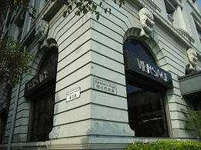
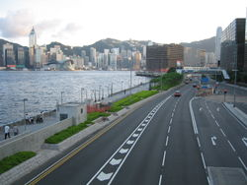
5.1 Salisbury Road (梳士巴利道)
5.2 Hong Kong Culture Centre （香港文化中心）
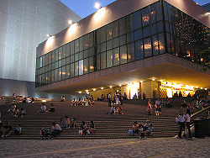
5.3 Hong Kong Space Museum（香港太空馆）
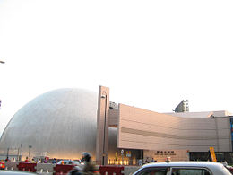
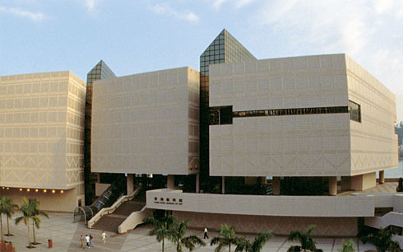
5.4 Hong Kong Musuem of Art(香港艺术馆)

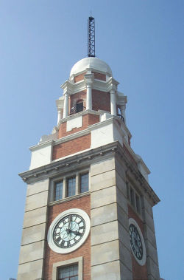
5.5 Clock Tower (钟楼)

5.6 Peninsula Hotel (香港半島酒店)
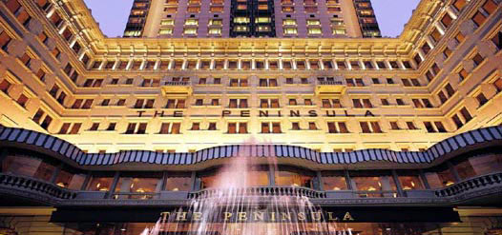
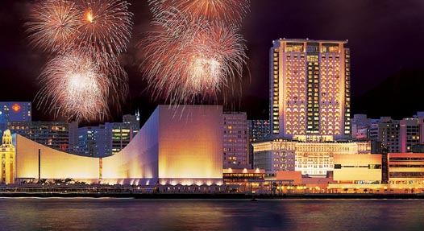
The Peninsula Hong Kong opened in 1928 is Hong Kong's first hotel and is also one of the most internationally recognizable hotels in Hong Kong.[1] It is located at the junction of Nathan Road and Salisbury Road in Tsim Sha Tsui, Hong Kong. Founded by members of the Kadoorie family, the hotel today is part of the Hongkong and Shanghai Hotels group headed by Sir Michael Kadoorie.

6. Nathan Road (弥敦道)
6.1 Chungking Mansions (重庆大厦)
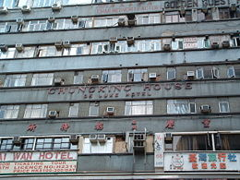
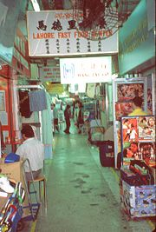
Chungking Mansions is a building located at 36-44 Nathan Road in Tsim Sha Tsui, Hong Kong. The building is well known as nearly the cheapest accommodation in Hong Kong with a single bed of US $8 one night. Though the building is supposedly residential, it is made up of many independent low-budget hotels, shops, and other services. The strange atmosphere of this building is sometimes called by some "the scent of Kowloon's Walled City".

Chungking Mansions features a labyrinth of guesthouses, curry restaurants, African bistros, clothing shops, sari stores, and foreign exchange offices. It often acts as a large gathering place for some of the ethnic minorities in Hong Kong, particularly Indians, Middle Eastern people, Nepalese, Sri Lankans, Bangladeshis, Nigerians, Europeans, Americans, Pakistanis, and many other peoples of the world.
The building was completed in 1961, at which time Chinese residents predominated. Now, after more than four decades of use, there are an estimated 4,000 people living in the Mansions.

6.2 Park Lane Shopper Boulevard (柏丽购物大道)
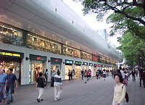
6.3 Former Kowloon British School (前九龙英童学校)

6.4 St Andrew's Church (圣安德鲁教堂)

7. Yau Ma Tei, Mong Kok (油麻地，旺角)

7.1 You Po Street Bird Garden (园圃街雀鸟花园)

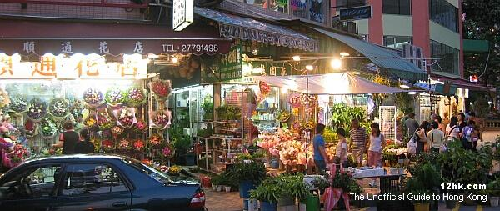
7.2 Flower Market (花墟)

7.3 Goldfish Market （金鱼街）

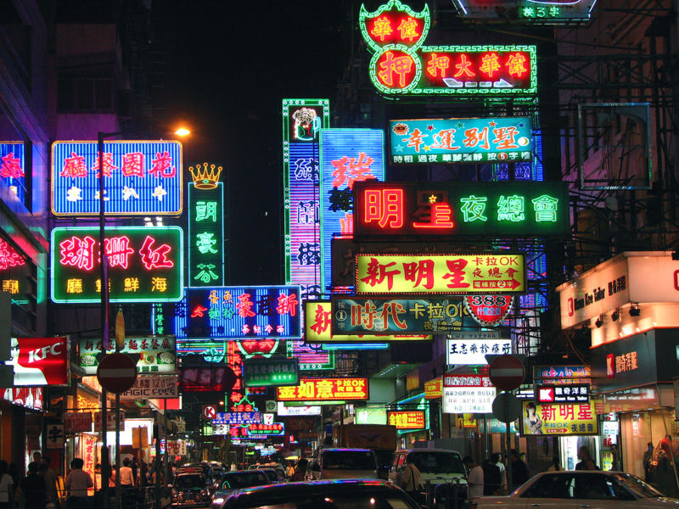
7.4 Portland Street (玻兰街) between Agyle Street and Dundas Street
Hong Kong's most famous red-light district.

7.5 Fa Yuen Street （花园街）

7.6 Ladie's Market (女人街)

7.7 Shanghai Street（上海街）

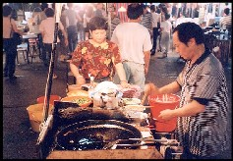
7.8 Temple Street Night Market（庙街夜市）

Activities: Bargaining, Fortune Telling, Chinese Opera, Dai Pai Dong, Reclamation St Canteens

7.9 Ho King Commercial Building (好景商业中心) Junction of Fa Yuen and Dundas St.
Shopping for Computer Software, Video Games, Pop Culture

7.10 Mongkok Computer Centre (旺角电脑中心) 8 Nelson St
Shopping for Computer Hardware, Laptop

7.11 Jade Market （玉器市场）

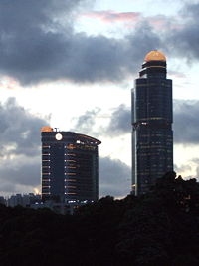
7.12 Tin Hou Temple (天后庙)

7.13 Langham Place (朗豪坊)
Langham Place is a business and commercial complex of shopping mall, hotel and office tower opened in the fourth quarter of 2004 in Hong Kong. Located in Mong Kok of Kowloon, the complex occupies two entire blocks defined by Argyle Street, Portland Street, Shantung Street and Reclamation Street. Shanghai Street separates the hotel and office tower from the shopping mall.
The complex was the result of an urban renewal project under Land Development Corporation, later known as Urban Renewal Authority (URA). The project is to cleanse and modernise a dilapidated area of Kowloon previously known as a red-light district, especially Portland Street.
The 59 storey Grade A office tower, Langham Place Office Tower, is the tallest in Kowloon with height of 255.1 m (837 ft). The complex has a gross floor area of 1.8 million sq. ft., houses the office tower, a 15 storey mall including 2 basements that spirals itself up to the 13th floor, and a 665 room hotel[1]. The mall is connected to the Mong Kok MTR station of the MTR via an underground passage (Exit C3), opened on March 3, 2005.

Meal Option:

Breakfast: In the Ramada Hotel

Lunch Option: Dim Sim in Tsim Sha Tsui

Option 1: Serenade Chinese Restaurant, 1st Floor Hong Kong Culture Centre).

Option 2: Jade Garden Chinese Restaurant, 4th Floor Star House, 3 Salisbury Road

Dinner: Temple Street Night Market
Day 4 Macau (澳门自由行) Monday

1. Jurbojet (From Hong Kong to Macau)
Schedule: 7:00am – 23:59pm Every 15mins
Price: Hong Kong – Macau $HK 134 (Night: $HK168 Weekend: $HK146 )
Macau – Hong Kong $HK 142 ( Night: $HK Weekend: $HK )
Departing Terminal: Macau Ferry Terminal (Hong Kong Sheung Wan)
提供日夜24小時高速客運服務，航程約一小時，船上有飲品和小食供應，航班往來於香港港澳碼頭和澳門之間。票價：普通位由142至176港元；豪華位由244至275港元；貴賓廂由976至1,650港元。查詢電話：澳門（853）8790 7039；香港（852）28593333，香港訂座電話：（852）2921 6688，網址：www.turbojet.com.hk。

入境簽證
來澳旅遊人士須具備有效的護照或旅行證件以及簽證。旅行證件的有效期最少要有三十天。參加旅行團的人士，其出入境簽證手續須由澳門的旅行社代辦。
持有下列各國和地區有效護照或證件人士入境無需簽證：
(1) 澳門居民；
(2) 持有葡萄牙當局所發旅遊證件之非葡籍人士；
(3) 持有有效進出澳門證件之中國籍人士，包括內地居民、香港居民、臺灣居民及海外華僑可逗留不超過三十天。
入境簽證可透過中華人民共和國駐外使領館向治安警察局出入境事務廳申請，並應在有效期內使用，否則即告失效。持有人准予在簽證上所註明之期限在澳門逗留。簽證也可在抵達澳門時再辦理，逗留期通常不超過三十天。
簽證分為個人、家庭和團體三種：
個人：100澳門元，十二歲以下兒童收費減半。
家庭：配偶或能證實其血緣關係的十二歲以下子女可以一起辦理，簽證費為200澳門元。
團體：團體簽證必須由澳門的旅行社申請辦理，人數最少十人，費用每人50澳門元。
如想獲得更多資料，可致電澳門治安警察局出入境事務廳：(澳門區號)853-28725488或瀏覽下列網址：http://www.fsm.gov.mo/psp/sm/default.htm

2. World Heritage Centre (世界遗产区)

2.1 Overview
“The Historic Centre of Macao” is a living representation of the city’s historic settlement, encompassing architectural legacies interwoven in the midst of the original urban fabric that includes streetscapes and piazzas, such as Barra Square(妈阁庙前地), Lilau Square(亚婆井前地), St. Augustine’s Square(岗顶前地), Senado Square(议事亭前地), Cathedral Square(大堂前地), St. Dominic’s Square(板樟堂前地), Company of Jesus Square and Camoes Square(耶稣会纪念广场). These major urban squares and streetscapes provide the linkage for a succession of over twenty monuments, including A-Ma Temple(妈阁庙), Moorish Barracks (港务局大楼), Mandarin’s House (郑家大屋), St. Lawrence’s Church (圣老楞佐教堂) , St. Joseph’s Seminary and Church (圣若瑟修院及圣堂), Dom Pedro V Theatre (岗顶剧院), Sir Robert Ho Tung Library (何东图书馆), St. Augustine’s Church (圣奥斯定教堂), “Leal Senado” Building (民政总署大楼), Sam Kai Vui Kun Temple (三街会馆（关帝庙)), Holy House of Mercy (仁慈堂大楼), Cathedral (大堂), Lou Kau Mansion (卢家大屋), St. Dominic’s Church (玫瑰堂), Ruins of St. Paul’s(大三巴牌坊), Na Tcha Temple (哪吒庙), Section of the Old City Walls (旧城墙遗址), Mount Fortress (大炮台), St. Anthony’s Church (圣安多尼教堂), Casa Garden (东方基金会会址), the Protestant Cemetery (基督教坟场) and Guia Fortress (东望洋炮台)(including Guia Chapel and Lighthouse) altogether known as “The Historic Centre of Macao”.
澳门历史城区是一片以澳门旧城区为核心的历史街区，其间以相邻的广场和街道连接而成，包括妈阁庙前地、亚婆井前地、岗顶前地、议事亭前地、大堂前地、板樟堂前地、耶稣会纪念广场、白鸽巢前地等多个广场空间，以及妈阁庙、港务局大楼、郑家大屋、圣老楞佐教堂、圣若瑟修院及圣堂、岗顶剧院、何东图书馆、圣奥斯定教堂、民政总署大楼、三街会馆（关帝庙）、仁慈堂大楼、大堂（主教座堂）、卢家大屋、玫瑰堂、大三巴牌坊、哪吒庙、旧城墙遗址、大炮台、圣安多尼教堂、东方基金会会址、基督教坟场、东望洋炮台（含东望洋灯塔及圣母雪地殿圣堂）等20多处历史建筑。
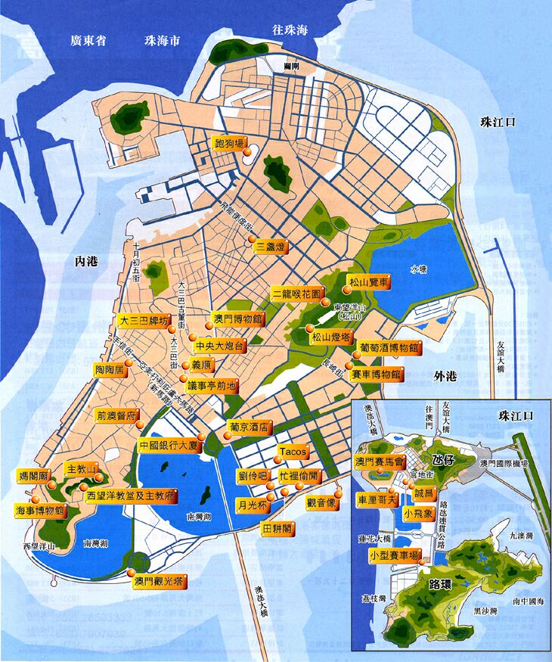
A-Ma Temple is located on the south-western tip of the Macao Peninsula overlooking Barra Square and the seashore. Around the corner of A-Ma Temple is the Moorish Barracks situated on Barra Street. Further up the road, the narrow street suddenly opens onto Lilau Square, the first residential district of the Portuguese settlers in history where the Mandarin’s House is just tucked behind the pastel façades across the street. Further up the road, Barra Street connects into Padre António Street and Lourenço Street where St. Lawrence’s Church stands. Behind the church, Prata Street leads to the junction of São José Street where the grand entrance to St. Joseph’s Seminary and Church is located. Walking alongside the granite wall on Prata Street and the adjoining Seminário Street, one arrives at the junction of Gamboa Lane. Climbing up the hill from there, the path leads to St. Augustine’s Square enclosed by a cluster of monuments - St. Augustine’s Church, Sir Robert Ho Tung Library and Dom Pedro V Theatre. Moving down Tronco Velho Lane to Almeida Ribeiro Avenue, the narrow streetscape opens onto the main city square - Senado Square. Situated at one end, the “Leal Senado” Building has a commanding view overlooking the entire square, flanked on both sides by South European-style buildings with the glimmering white façade of the Holy House of Mercy standing in its midst. Tucked behind the commercial shop fronts to the left of the Leal Senado Building is the Sam Kai Vui Kun Temple. Climbing up the slope alongside the Holy House of Mercy, one eventually lands at Cathedral Square on the hilltop where the Cathedral is located. Turning back down to St. Dominic’s Square, one passes a typical Chinese courtyard house compound – the Lou Kau Mansion. St. Dominic’s Church is located at the junction of Senado Square and Dominic’s Square. Ascending from the base of Mount Hill from this urban piazza along Palha Street, the bluestone cobbled road leads to the grand façade of the Ruins of St. Paul’s, with Mount Fortress to the side of it. Behind the majestic church front, is the miniature Na Tcha Temple and Section of the Old City Walls. Further down the hill, the linear route ends at St. Anthony’s Church, the Casa Garden and the Protestant Cemetery. Standing on the highest hill of Macao Guia Hill, Guia Fortress, Chapel and Lighthouse are visible along the skyline of the peninsula.

2.2 Ruin's of St Paul's (大三巴牌坊)
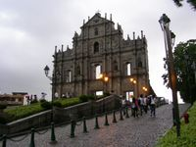
大三巴牌坊是聖保祿教堂的前壁遺跡，是澳門著名的名勝。
教堂原本由一名意大利籍的耶穌會神父設計，由日本工匠以鬼斧神工的技術協助建成。1602年奠基，1637年全部竣工，而教堂前一段長石階則於稍後完成。
這間教堂與火結下不解之緣，從其雛型起始，至現時僅存的前壁牌坊，先後經歷三次大火，屢焚屢建，是一所活生生的歷史見證。
1835年1月26日黃昏，聖保祿教堂失火，一發不可收拾，焚燒了兩個多小時，整幢教堂幾乎付諸一炬，幸好教堂最珍貴的前壁仍能保存屹立，成為今日的大三巴牌坊，期間曾數度修葺，最近一次大規模的維修保養工程於1991年進行。
聖保祿教堂的建築，糅合了歐洲文藝復興時期與東方建築的風格而成，中西合壁、雕刻精細，單獨是大三巴牌坊的造價，三百年前已達三萬兩銀。
遊覽大三巴牌坊，除欣賞巍峨壯觀的前壁之外，還要細心瀏覽壁上精緻的浮雕及其意義。
從牌坊頂部逐層而下，先是一個高高在上的十字架，其下再分三層，每層的壁龕均藏有一銅像，是澳門早年的製炮工廠出品。十字架對下是一具銅鴿，據云代表聖神，像的旁邊圍有太陽、月亮及星辰的石刻，象徵聖母童貞懷孕一剎那時光。
銅鴿之下是一個耶穌聖嬰像，像的旁邊刻有用以釘死耶穌的工具。
第三層的正中刻著一個童貞聖母雕像，旁邊以兩種花朵圍繞──分別是牡丹和菊花，前者代表中國，後者代表日本。雕像左方還刻「永恆之眾」，一艘「葡式帆船」及「面目猙獰的魔鬼」。右方則刻有代表生命之樹及聖母征服魔鬼並刺穿其骷髏的圖像，象徵正義戰勝死亡。
第三層的下面有一層壁龕，有四位耶穌會聖人雕像。牌坊的底部有三面大門，正面的大門上刻有拉丁文MATER DEI字樣，意即「天主聖母」，兩側的門上刻有耶穌的記號 "IHS"。
從大三巴牌坊鄰近的大炮台城堡下望，可以看見整座教堂原跡及其後面廣場的一些石刻。
1990年至1995年間，政府在昔日聖堂的地點進行了維修工程，並建成了一個天主教藝術博物館，館內收藏了本澳各教堂和修院具代表性的畫作、雕塑和禮儀飾物等展品。

2.3 Largo do Senado(议事亭前地)

议事亭前地占地面积为3700平方米，整个广场路面由碎石子铺就，组成波浪形的图案。
广场四周的建筑物(旅游局、邮政局和仁慈堂等)属典型的欧陆建筑风格，充满异国风情。
广场中央有一喷泉。广场上的碎石路一直延伸到圣母玫瑰堂和大三巴牌坊前。

2.4 Guia Lighthouse (东望洋炮台、教堂、灯塔和防空洞)
东望洋炮台位於澳门半岛的最高点，建於十七世纪。炮台上的小圣堂──圣母雪地殿教堂──建於1637年，具有十七世纪葡国修院的建筑特色。经过1996年的修缮，恢复了圣堂和厅院的原貌。修缮过程中，在墙壁上发现被覆盖了许久的壁画，这些壁画糅合了中西文化的特色，具有极高的艺术价值。
东望洋灯塔是中国沿海地区的第一座灯塔，由一名澳门土生葡人所建。灯塔旁有一望远镜，供游客俯瞰市内景色。
於东望洋 (松山) 之巅，除了著名的灯塔外，还筑有数座炮台堡垒及防空洞。防空洞由四组隧道组成，是昔日的军事禁区，守卫森严。四组防空洞最长为456公尺，最短则只有47公尺。内有发电机、休息室及贮油池，并有登上灯塔炮台的升降机等。重新修葺後的防空洞於2003年10月初对外开放。今天游人见到的不再是昔日阴森可怖的一面，取而代之的是一个全新面貌的展示廊，游人可从墙上摆放的珍贵历史图片及介绍，领略防空洞的真实状况。
开放时间∶上午十时至下午五时 (逢星期一休息，公众假期除外) 免费入场。
查询电话∶(853) 8394 3703 / (853) 8988 4000
网址: www.iacm.gov.mo/scrweb/airraidshelter/air_raid.htm
二龙喉公园位於东望洋山山麓。从东望洋山炮台可徒步下山或乘坐观光缆车下山去二龙喉公园，坐缆车只需时一分钟左右。
2.5 Forteleza do Monte大炮台

座落在大三巴牌坊侧的大炮台建於 1617 至 1626 年间，属圣保禄学院和圣保禄教堂的一部分。大炮台上的古炮在 1622 年抵御荷兰人的入侵时，发挥了重要的作用。大炮台曾是总督官邸。1835 年的一场大火烧毁了大炮台上的所有建筑和圣保禄学院，圣保禄教堂被烧得只剩下前壁，即今日的大三巴牌坊。
大炮台上有大片空地，绿草如茵，古木参天，古炮雄距於旁。本地市民和游客经常前往，从这儿可眺望澳门的全景，还可以看见圣保禄教堂的遗迹。
大炮台上原有一座南欧式的建筑，初为兵营，後为气象台的所在地。1998年，澳门博物馆在这里落成。博物馆共有三层，通过展品向参观者展现在数百年当中，居住在澳门的不同民族和平共处的生活状况、历史面貌以及当代澳门城市生活的特色和对未来的展望。
2.6 Walking Routes
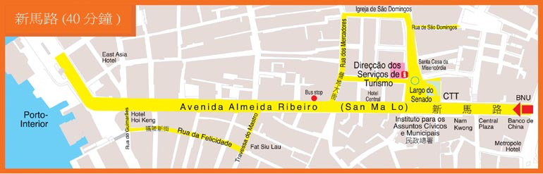
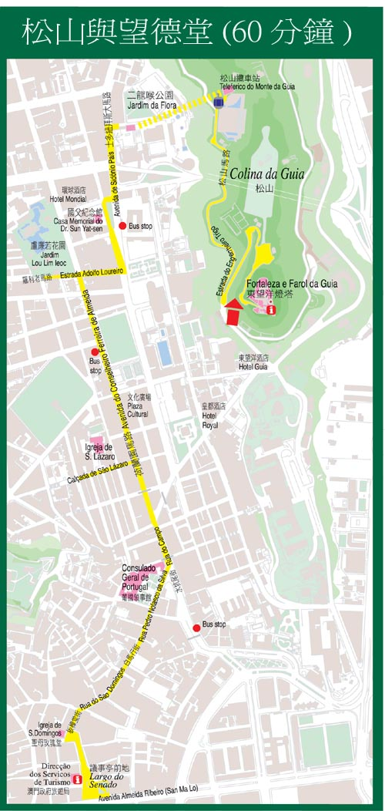
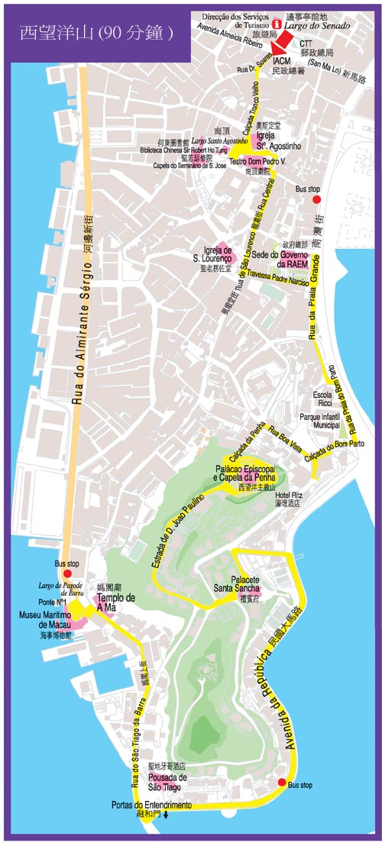
3. Macau Fisherman's Wharf (澳门渔人码头)

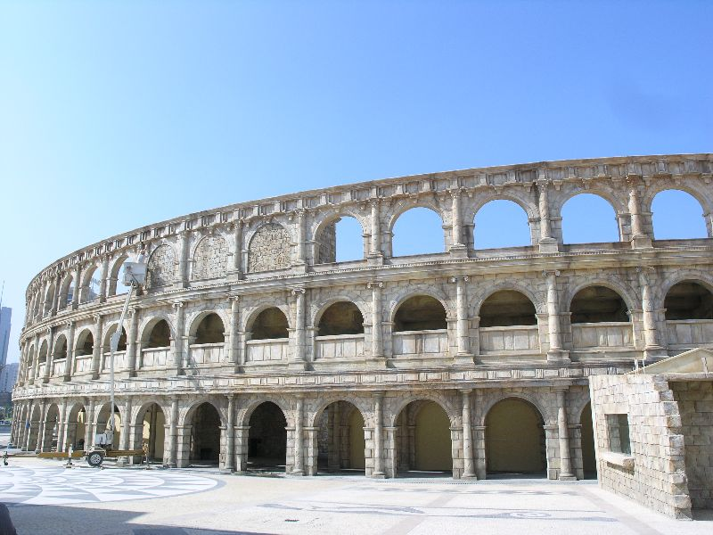
澳门渔人码头是澳门首个以主题式设计的综合娱乐旅游新景点，由澳门知名商人何鸿燊博士及周锦辉先生联合发展，总投资约达港币十九亿元。澳门渔人码头座落于外港新填海区海岸，占地超过111,500平方米，集娱乐、购物、饮食、酒店、游艇码头及会展设施于一体，结合不同建筑特色及中西文化，务求使游客突破地域界限，体验不同地区的感受。而区内多元化的娱乐设施必定能使澳门渔人码头成为举家同游的好去处。澳门渔人码头的落成相信将为本澳旅游业展现全新的旅游面貌。
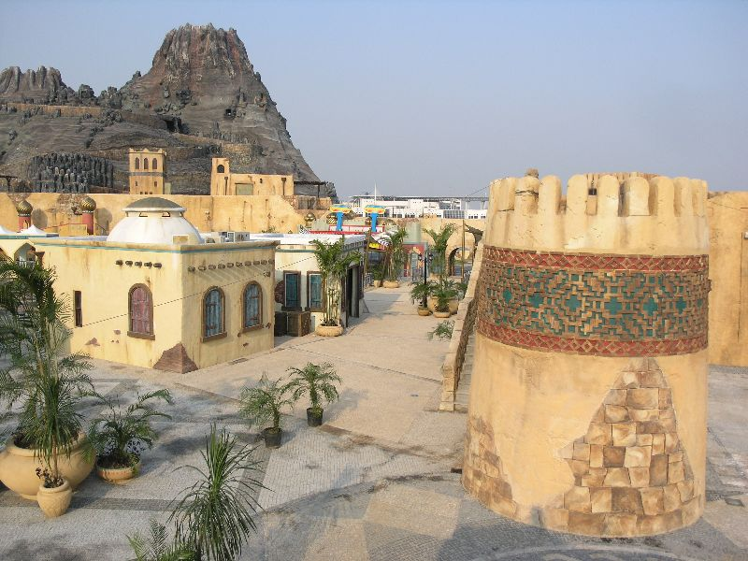
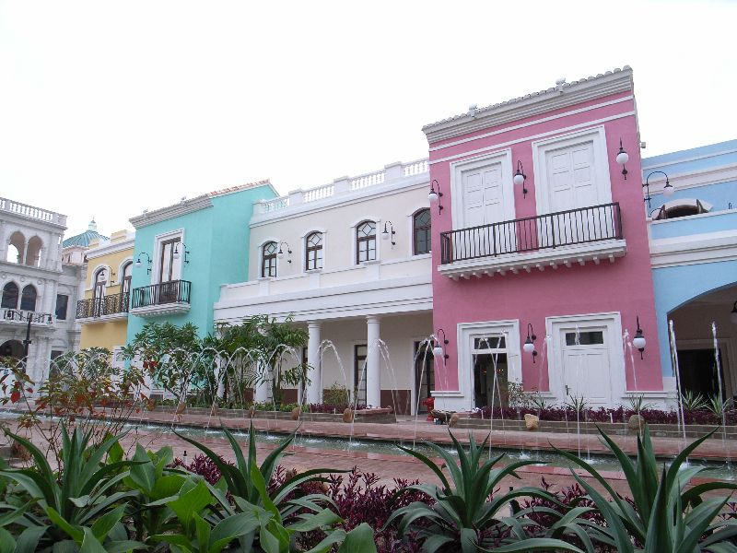
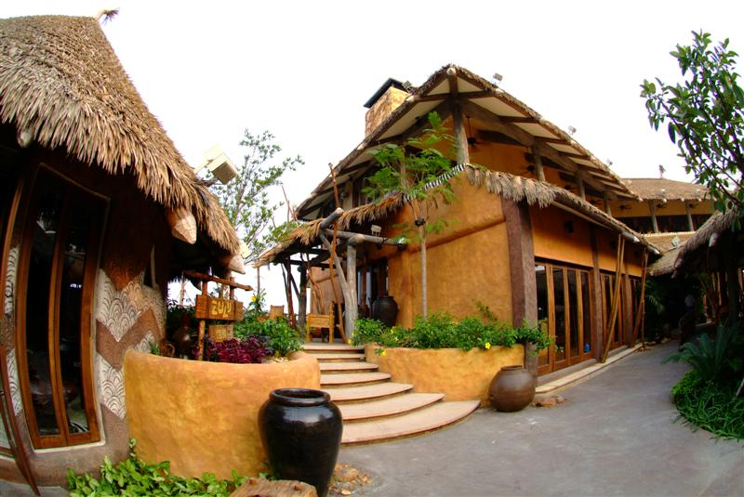
澳门渔人码头不只是一个购物中心, 更是一个娱乐及消闲地带. 我们更会每日举行各式各样的表现节目及推广活动, 吸引更多的顾客前来消闲购物。

4. Wine Museum 葡萄酒博物馆
葡萄酒博物馆於一九九五年开幕，介绍葡萄酒酿制文化的发展，由公元前一万年的高加索时代到今日，特别是位於伊比利亚半岛的葡萄牙。展馆收藏了各式古老酿酒器皿和用具，如旧式的榨葡萄机；另外，酒牌上列有多种葡国佳酿，游客可品尝其中一种美酒。
进入博物馆，就会看到运载葡萄的牛车和一幅以葡萄园和葡萄酒为主题的瓷砖画，在它後面的长廊内，可以了解到葡萄酒酿制的发展过程，认识南欧国家葡萄酒文化，特别是位於伊比利亚半岛的葡萄牙（长廊现正进行整修工程，暂时关闭）。
经过这个富历史信息的区域，我们来到了地窖，这里珍藏了很多葡萄酒，在昏黄的空气中仿佛飘浮著淡淡的酒香。在这个古色古香的地窖中，观众可从有两百年历史的压榨机、运载酒桶的骡车、羊皮酒容器、铜蒸馏器和大大小小的酒桶中了解到古老的酿酒方法。
葡萄酒博物馆的面积虽然不大，却收藏了一千一百一十五种不同品牌的葡萄酒，其中七百五十六种是销售的牌子，另外三百五十九种作收藏用，其中最古老的一瓶是一八一五年的波尔图酒。
博物馆内亦展出了葡萄牙不同地区的各式民族服装。
当了解酿酒和葡萄种植历史後，行程还未正式结束，因为您还没尝过这里的甘醇美酒，所费无几，就会令人齿颊留香，何乐而不为呢?
地址∶澳门高美士街旅游活动中心内
开放时间∶每日上午十时至下午六时，逢星期二休馆
票价∶成人∶澳门币15元 (包括尝酒)
 十一岁至十八岁∶澳门币5元
 十岁以下小童及六十岁以上长者免费入场
 参观大赛车博物馆和葡萄酒博物馆套票(包括尝酒)∶澳门币20元
电话∶（853）8798 4188
传真∶（853）28706076
到达的公共汽车有∶1A,3,3A,10,10A,10B,12,17,23, 28A,28B,28C,32
4. Macau Tower (澳门旅游塔)

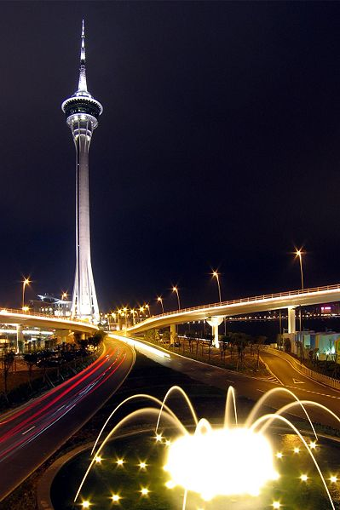
Macau Tower (traditional Chinese: 澳門旅遊塔), also known as Macau Sky Tower, is a tower located in the former Portuguese colony of Macau, now a Special Administrative Region of the People's Republic of China. The tower measures 338 m (1,109 ft) in height from ground level to the highest point. An observation deck with panoramic views, restaurants, theaters, shopping malls and the Skywalk X, a thrilling walking tour around the outer rim. It offers the best view of Macau and in recent years has been used for a variety of adventurous activities. At 233 meters, the Macau Tower's tethered "skyjump" and Bungy jump by world renowned AJ Hackett [1] from the tower's outer rim, is the highest in the world. The tower was created by architecture firm of Craig Craig Moller.
The tower is one of the members of the World Federation of Great Towers. Besides being used for observation and entertainment, the tower is also used for telecommunications and broadcasting.

无论是在晨光下饱览珠海对岸景致，又或是于晚上府瞰璀璨的醉人美景，澳门旅游塔会展娱乐中心均是您的最佳选择。您可乘坐子弹升降机由下而上走访塔内每层的特色，先到观光层欣赏四周风景，跟着品尝一下360°旋转餐厅的美味自助餐，然后再四处走走尽享悠闲。

- 塔身最高处达338米

- 观光主层离地223米高

- 为全球第十位及全亚洲第八位之最高独立式观光塔

- 于塔内最高的观光层远眺四周，可饱览55公里以内的风景

- 塔身可承受高达每小时400公里的风速

- 塔顶以钢铁铸造的长杆高90米

- 由纽西兰CCMBECA公司之着名建筑师Gordon Moller设计

- 澳门旅游塔乃世界高塔联盟之会员

6. Gambling in Macau

6.1 Hotel Lisboa (葡京游乐城)

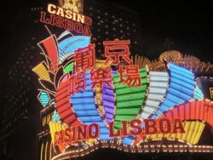
Gambling is Macau's biggest industry and busloads arrive daily from mainland China to try their luck. In addition, many Hong Kongers arrive on weekends with the same aim. For many years, the Casino Lisboa was the most famous and a landmark well known to people outside Macau, but it is being eclipsed by Sands Casino which opened in 2004.

Most casinos are located along the waterfront on the southern side of Macau Peninsula. North of the Lisboa is a strip with many smaller casinos, a number of hotels and bars, and quite a few restaurants. This can be one of the more interesting areas of Macau; among other things it has quite a good Indian restaurant and several Portuguese ones. However, parts of it are also fairly sleazy, with lots of hookers and touts, so some caution is in order. New casinos have also opened in the area called NAPE south of Avenida de Amizade, including Wynn Macau and Sands Macau.
All this is going to be overtaken by the new development on the Cotai Strip, which is being made into "The Las Vegas Strip of the East". The Venetian Macao started operations here in August 2007 and many others will follow. There are also several casinos on Taipa, including the Crown Macau.
There are ATM machines available at either casino as well as forex facilities to change your money. Gamblers are required to be at least 18 years of age to be allowed to play. Interestingly, local civil servants are not allowed to enter the casinos with the exception of the first three days of the Chinese new year.

Day 5. Shopping (购物日)(Tuesday)

Morning

1. Statue Square(皇后像廣場)

皇后像广场（Statue Square）是香港的一个广场，位于香港岛中环，为早年维多利亚城的地标性广场建筑。

随着香港沦陷及战后的城市发展，皇后像广场现时已经没有任何英国皇室成员的铜像，仅保留了一座纪念银行家昃臣的铜像。政府于1960年代将广场重建成现貌，供市民休憩之用。
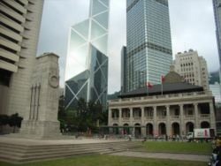
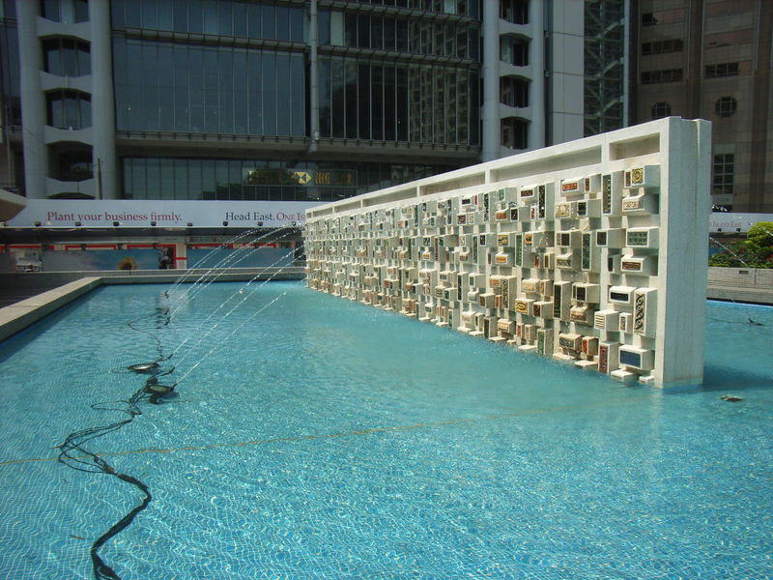
历史
(1920年代)皇后像广场原名中央广场，用地是1880年代填海所得的土地。为纪念维多利亚女王登基60周年，香港政府铸造了一座女王的铜像，并于1896年5月28日在中央广场揭幕。重达3吨的女王铜像，放置位于中央广场核心位置（遮打道与获多利街交界）的拱顶亭座之内，与卜公码头构成中轴线。1897年，政府将中央广场更名为皇后像广场，“皇后”一词实际是政府官员将英文“女皇”一词“Queen”误译所致。
广场南部为一片草坪，中央为贯通德辅道中与遮打道的获多利街。为了表扬香港上海汇丰银行总经理昃臣(Sir Thomas Jackson))对香港经济的贡献，他的铜像于1906年获安放于广场之内。广场北部则放置多尊英国皇室成员的铜像，包括英皇爱德华七世及乔治五世的铜像，两座铜像均于1907年2月6日由访港的干诺公爵主持揭幕。1909年，广场放置了爱德华七世妻子雅丽珊皇后的铜像。1923年5月3日，广场放置了港督梅含理的铜像。同年，广场北部东侧的和平纪念碑建成，纪念在第一次世界大战的阵亡将士。
香港日治时期，皇后像广场中的女皇铜像被日军运往日本，准备熔掉成为制造武器的原料。而拱顶亭座则被刻有占领香港告谕的石碑所封，宣告香港已经被日本占领。第二次世界大战结束后，拱顶亭座因为毁坏不堪而被拆卸，而遮打道得以扩阔。香港政府透过驻日盟军总部寻回爱德华七世伉俪（其后运返英国）、维多利亚女王及昃臣的铜像，昃臣铜像其后重置于皇后像广场南面，而维多利亚女王则重置于1957年落成的维多利亚公园内。由于皇后像广场的英文名称是Statue Square，意即“铜像广场”，因此很多外地人士误以为皇后像广场是因昃臣的铜像而得名。
重建与现况

政府于1950年代重建皇后像广场，加建了喷水池、凉亭及园林绿化设施，具包浩斯的建筑风格。广场北面的干诺道中行人隧道于1959年4月2日启用，是香港首条行人隧道，连接爱丁堡广场码头及香港大会堂。1980年2月12日，地铁中环站及其位于皇后像广场的出入口（K出口）启用，川流不息的行人成为了皇后像广场平日的特色景象。
位处中环商业区的皇后像广场，自1960年代就成为举行如香港节及主权移交纪念等大型公众活动的主要场地，随着最高法院大楼于1985年改建为立法局大楼，皇后像广场及遮打花园亦成为了集会示威的主要场地。1990年代，随着来港的菲律宾佣工每逢假日都在广场一带集会休憩，遮打道在假日都被划为行人专用区，一些专栏作者就曾经将皇后像广场讥为“宾妹广场”。
自2003年起，皇后像广场在每年12月均会举行香港缤纷冬日节，广场一带仿照北欧芬兰的圣诞老人镇布置，并有全香港最高的户外圣诞树，成为每年的特色活动。
禁烟安排
自2007年1月1日相关禁烟条例生效后，此场地全面禁烟。
附近建筑物
- 香港汇丰总行大厦
- 香港立法会大楼 (The Legislative Council Building)
- 太子大厦
- 遮打花园
- 爱丁堡广场
- 香港大会堂
- 香港会所大厦
- 香港文华东方酒店

1.1 HSBC Main Building, Hong Kong (香港汇丰银行总部）
The HSBC Main Building (traditional Chinese: 香港滙豐總行大廈) is the headquarters building of The Hongkong and Shanghai Banking Corporation Limited in Central, Hong Kong. It is located along the southern side of Statue Square at the location of the old City Hall, Hong Kong (built in 1869, demolished in 1933). The previous HSBC building was built in 1935 and pulled down to make way for the current building. The address remains as 1 Queen's Road Central, Central. The building can be reached by a 5-minute walk from Exit K of Central MTR Station and facing Statue Square.
The first HSBC (then known as the Hongkong and Shanghai Bank) building was Wardley House, used as HSBC office between 1865 to 1882 on the present site. In 1864 the lease cost HKD $500 a month. After raising a capital of HKD $5 million, the bank opened its door in 1865.[2] It was demolished in 1886 and rebuilt in the same year.

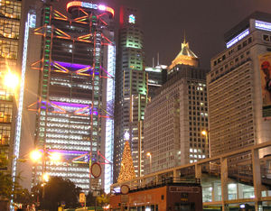
The main feature of the second building design was the division of the structure into two almost separate buildings. The building on Queen's Road Central was in Victorian style with a verandah, colonnades and an octagonal dome, whereas the arcade which harmonized with the adjacent buildings was constructed on Des Voeux Road.

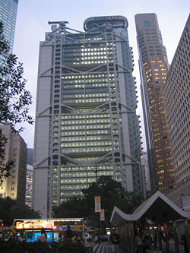
In 1935, the second building was demolished and a third design was erected. The third design used part of the land of the old City Hall, and was built with the Chicago school style. This third building had, for a period of time after completion, been the tallest building between San Francisco and Cairo. During the Japanese occupation of Hong Kong, the building served as the government headquarters. Locally, it was the first building in Hong Kong to be fully air-conditioned.

By the 1970s the bank had outgrown its headquarters; departments were scattered into offices all over Central Hong Kong, and it was obvious that such a "solution" to the space limitations could not continue indefinitely. In 1978 the bank decided to tear down its headquarters and rebuild it again. The building was finished on November 18, 1985. At the time, it was the most expensive building in the world (c.a.HK$5.2 billion, roughly US$668 million).
The first major addition to the building, designed by Hong Kong's One Space Ltd, was completed on November 23, 2006, in the form of a ground floor lobby that improves security access to the upper floors and creates a prestigious reception area. Its design and construction included the installation of the "Asian Story Wall", a multimedia installation comprised of twin banks of 30 seamless plasma screens (the largest installation of its kind in Hong Kong) displaying archived bank heritage and artworks.

The new building was designed by the British architect Norman Foster and built by Wimpey Construction. From the concept to completion, it took 6 years (1979-1985). The building is 180-metres high with 47 storeys and four basement levels. The building has a module design consisting of five steel modules prefabricated in the UK by Scott-Lithgow Shipbuilders near Glasgow, and shipped to Hong Kong. 30,000 tonnes of steel and 4,500 tonnes of aluminium were used. It is rumoured that the building's modular design enables it to be dismantled and moved, if there was any possibility of a disrupted handover to the People's Republic of China.

The new Lobby and its 2-part Asian Story Wall were designed by Greg Pearce, of One Space Limited. Pearce was also the Principal Architect of the Hong Kong Airport Express (MTR) station. Conceived as a minimalist glass envelope, the new lobby is designed to be deferential to Foster's structure and appears almost to be part of the original.
The building is also one of the few to not have elevators as the primary carrier of building traffic. Instead, elevators only stop every few floors, and floors are interconnected by escalators.

The main characteristic of HSBC Hong Kong headquarters is its absence of internal supporting structure.

Another notable feature is that natural sunlight is the major source of lighting inside the building. There is a bank of giant mirrors at the top of the atrium, which can reflect natural sunlight into the atrium and hence down into the plaza. Through the use of natural sunlight, this design helps to conserve energy. Additionally, sun shades are provided on the external facades to block direct sunlight going into the building and to reduce heat gain. Instead of fresh water, sea water is used as coolant for the air-conditioning system.
All flooring is made from lightweight movable panels, under which you can find a comprehensive network of power, telecommunication, and air-conditioning systems. Hence installation of equipment or computer terminals becomes far easier.
Because of the urgency to finish the project, the construction of the building relied heavily on off-site prefabrication; components were manufactured all over the world. For example, the structural steel came from Britain; the glass, aluminium cladding and flooring came from the United States while the service modules came from Japan.
The inverted ‘va’ segments of the suspension trusses spanning the construction at double-height levels is the most obvious characteristic of the building. It consists of eight groups of four aluminium-clad steel columns which ascend from the foundations up through the core structure, and five levels of triangular suspension trusses which are locked into these masts.

The early British settlers in Hong Kong had an interest in Feng Shui; thus, most of the earliest buildings in Hong Kong, and many buildings constructed thereafter, were built with the philosophies of Feng Shui in mind. The Chinese and even the British believe that those who have a direct view of a body of water--whether it is a river, a sea, or an ocean--are more likely to prosper than those who do not (water is strongly associated with wealth in Feng Shui). The HSBC building has a wide open area (the Statue Square) in front of it, with no other buildings blocking its view of Victoria Harbour; thus, it is considered to have "good feng shui."

Even though the Hong Kong Government is proposing extending the existing coastline further out into the harbour in its latest land reclamation project, it will still set aside space so that no new developments will block the HSBC Building's view of the harbour. (It has been said that the HSBC is guaranteed its view of the harbour by the government. )
It is believed that the Bank of China (Hong Kong) building is to resemble a sword, slicing down at the HSBC building, and in order to counter-that there is a cannon looking object at the top left of the tower.
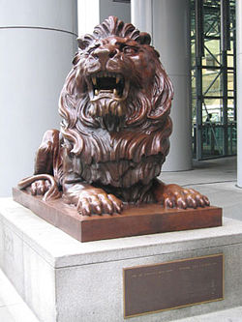
Two bronze lion statues are located behind the building. The statues were cast in Shanghai in 1935 and brought to Hong Kong. Like the other statues of Statue Square, the two lion statues were displaced to Japan for melting by the then Japanese administration during World War II. They were rediscovered at the end of the war there, and brought back to their original location. Bullet impacts from the Battle of Hong Kong in WWII are still visible on the statues. One of the lion statues had a small explosive embedded in it; it remained undiscovered until the early 1990s, when it was removed by police's explosive unit.

From a "Feng Shui" point of view, the two bronze lion statues in front of the HSBC headquarter are believed to contribute to the steady revenue of the bank. Although even in Asia, not every architect believes in Feng Shui, most of their customers do.
The original pair of lions are kept at a museum in Shanghai. The lions at HSBC Hong Kong Headquarters are the second pair. A third pair is kept in HSBC Group Headquarters in London, and a fourth pair is located at its former branch in Shanghai.
The left lion (the one with the mouth open) is named Stephen, after the general manager of Hong Kong branch A. G. Stephen; and the right is named Stitt, after the general manager of Shanghai branch at the time.
Rumour has it that Stitt used to have its mouth open as well, but this would allow it to "breathe in" the eastern wind, giving it life at night and became a menace to the public. Thus Stitt was recast with its mouth closed.

2. Central Shopping (中环购物)

2.1 The Landmark Centre （置地广场）

The Landmark is an office and shopping development owned by Hong Kong Land in Central, Hong Kong. It is commonly known as the home of numerous prestigious international brands and the gathering place of well-heeled shoppers

2.2 The Prince's Building （太子大厦）
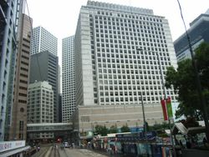
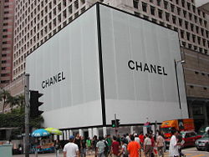
2.3 Other Shopping Malls
The Pedder Building
Seibu
Lane Crawford

3. Central Plaza (中环广场)

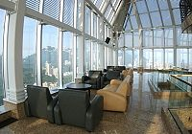
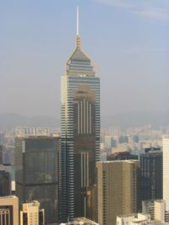
Central Plaza (traditional Chinese: 中環廣場) is the second tallest skyscraper in Hong Kong. With a height of 374 m / 1227 feet, Central Plaza is only surpassed by 2 IFC (415 m/1,362 ft) in Central. The building is located at 18 Harbour Road, in Wan Chai on Hong Kong Island. It used to be the tallest building in Asia from 1992 to 1996, until the Shun Hing Square in Shenzhen, People's Republic of China, was built. The 78-storey building was completed in August 1995. The building surpassed the Bank of China Tower as the tallest building in Hong Kong until the completion of 2IFC.

Central Plaza was also the tallest reinforced concrete building in the world, until it was surpassed by CITIC Plaza, Guangzhou. The building uses a triangular floor plan. On the top of the tower is a four-bar neon clock that indicates the time by displaying different colors in 15 minute intervals, blinking at the change of the quarter.
An anemometer is installed on the tip of the building's mast; the anemometer sits at 378 metres (1,240 ft) above sea level. The mast has a height of 102 m (335 ft). It also houses the world's highest church--Hong Kong City Church.

Central Plaza is made up of two principal components: a free standing 368 m (1,207 ft) high office tower and a 30.5 m (100 ft) high podium block attached to it. The tower is made up of three sections, a 30.5 m (100 ft) high tower base forming the main entrance and public circulation spaces, a 235.4 m (772 ft) tall tower body containing 57 office floors, a skylobby and five mechanical plant floors and the tower top consist of six mechanical plant floors and a 102 m (335 ft) tall tower mast.

The ground level public area together with the public sitting out area forming an 8,400 m² (90,400 sq ft) landscaped garden with richly ornate fountain, trees and artificial stone paving dedicated for public enjoyment. No commercial element is included in the podium. The first level is a public thoroughfare for three pedestrian bridges linking the Mass Transit Railway, the Convention and Exhibition Center and the China Resource Building. By turning these space to public use, the building got 20% plot ratio more as bonus. The triangular building shape of the tower is not truly triangular but with its three corners cut off to provide better internal office spaces.

4. Hong Kong Convention and Exhibition Centre (香港会议展览中心)

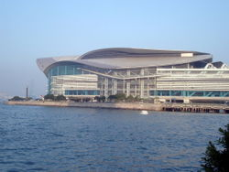
The Hong Kong Convention and Exhibition Centre (traditional Chinese: 香港會議展覽中心; often abbreviated as HKCEC or 會展) is one of the two major convention and exhibition venues in Hong Kong, along with AsiaWorld-Expo. It is located in Wan Chai North, Hong Kong Island. Built along the Victoria Harbour, it is linked by covered walkways to nearby hotels and commercial buildings.
The original building was built on reclaimed land off Gloucester Road in 1988. The glass curtain was the world's largest at the time, overlooking the Victoria Harbour on three sides.

The second phase of the centre, located on an artificial island, was constructed from 1994 to 1997, and features a bird-like rooftop (also referred to as a turtle by some critics). It is connected to the old phase with an atrium link - a sky bridge, and to Convention Road with two road bridges. The project took only 48 months from reclamation to completion, which is extremely fast for a building project of this size. The main constructor of the extension was a joint venture named Hip Hing Construction Co Ltd Dragages et Travaux Publics. The atrium link will be rebuilt and expanded.
The complex's construction was financed by New World Development, with the Renaissance Harbour View Hotel, Grand Hyatt Hong Kong and Harbour View Apartments on top of it.
The HKCEC has a total internal exhibition area of more than 28,000 square metres with 16-metre headroom and spans ranging from 26 m to 81 m. Its multi-curved steel roof has a total area of 40,000 m², while the 7,000 m² fully glazed main entrance foyer has a clear headroom of about 60 metres.

3.1 The Golden Bauhinia Square (金紫荆广场)
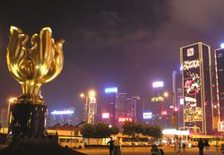
The Golden Bauhinia Square (traditional Chinese: 金紫荊廣場; pinyin: Jīn Zǐjīng Guángchǎng) is an open area in Wan Chai North, Hong Kong. The square was named after the giant statue of a golden Bauhinia blakeana at the centre of the area, situated outside the Hong Kong Convention and Exhibition Centre, where the ceremonies for the handover of Hong Kong and the establishment of the Hong Kong Special Administrative Region was held in July 1997. A flag-raising ceremony is held there every day at 8:00am. It is a tourist attraction.

Afternoon：

5. Wan Chai Shopping （湾仔购物）
Wan Chai is a metropolitan area situated at the western part of the Wan Chai District in northern Hong Kong Island, in Hong Kong, China. Its boundaries are Canal Road in the east, Arsenal Street in the west and Bowen Road in the south. The area north of Gloucester Road is often called Wan Chai North. Wan Chai is one of the busiest commercial areas in Hong Kong with many small to medium-sized companies. Wan Chai North features office towers, parks, hotels and an international conference centre. As one of the first areas developed in Hong Kong, the locale is highly-populated yet with noticeable residential zones facing urban decay. Arousing much public concern, the government has put an effort in district regeneration in recent years. There are many unique buildings and skyscrapers, the most notable ones being the Hong Kong Convention and Exhibition Centre (HKCEC), Central Plaza and Hopewell Centre.
Wan Chai originally began as Ha Wan (下環), literally meaning "a bottom ring" or "lower circuit".[1] As one of the earliest developed areas in Hong Kong. Central, Sheung Wan, Sai Wan and Wan Chai are collectively known as the four rings (四環) by the locals. Wan Chai literally means "a cove" in Cantonese, but the area itself is no longer a cove due to drastic city development and continual land reclamation.
Wan Chai was first home to the many Chinese villagers living along the undisturbed coastlines in proximity to Hung Shing Temple. Most of them were fishermen, who worked around the area near Hung Shing Temple overlooking the entire harbour. As the God of the Sea, Hung Shing Ye was one of the symbols worshiped by the locals.

When the British arrived in Colonial Hong Kong, Wan Chai began modernizing in the 1840s as a high-class commercial centre. Spring Gardens was one of the focal points of development. By the 1850s the area was already becoming a Chinese residential area. There were dockyards in Ship Street and McGregor Street for building and repairing ships. The edge of Sun Street, Moon Street and Star Street is the original site of the first power station in Hong Kong, operated by the Hongkong Electric Company, which began supplying power in 1890. One of the first water-front military hospitals was the Seaman's hospital built in 1843 as part of the Royal Naval Dockyard for the British Royal Navy. It was later revitalized as the Ruttonjee hospital.
Several renowned schools were located in Wan Chai in the past. One of these was established by the famous traditional teacher, Mo Dunmei (莫敦梅). Started as a shushu (書塾) in 1919, the school was renamed Dunmei School (敦梅學校) in 1934. It taught classical Chinese writings and Confucian ethics.
During the Japanese occupation in the 1940s, many bombardments took place. Stories of cannibalism, starvation, torture and abuses by Japanese soldiers, and child labourers were told. Senior residents recall vividly how they survived the hardships. The Dunmei school was closed during the Japanese occupation period. After the war, the school continued to provide Chinese education for children from families of higher income.
During the 1950s the pro-Communist underground cell network Hailiushe (海流社) was headquartered in the rooftop of a multi-story house on Spring Garden Lane. The group was successfully raided by the Hong Kong police.
Prostitution is one of the oldest occupations in Wan Chai. There are numerous historical western accounts of women trading sex for western merchandise as soon as sailors got off the trading ships. In the 1960s, Wan Chai became legendary for its exotic night life, especially for the US service men resting there during the Vietnam war. Despite rapid changes due to reclamation and redevelopment, the presence of sex workers operating among ordinary residents continue to be a distinct feature of the area. Some of the lifestyle has been illustrated in the past in movies such as The World of Suzie Wong.
Wan Chai's HKCEC was the site of the Hong Kong handover ceremony in 1997. The WTO Ministerial Conference in 2005 was also one of the largest international events ever hosted in Hong Kong, with 148 nations participating.

6. Causeway Bay Shopping （铜锣湾购物）
Causeway Bay or East Point is a heavily built-up area of Hong Kong, located on the northern shore of Hong Kong Island, and covering parts of Wan Chai and Eastern districts. The Chinese name is also romanized as Tung Lo Wan as in Tung Lo Wan Road (銅鑼灣道). The rent in the shopping areas of Causeway Bay is ranked the second in the world, with the Fifth Avenue (Manhattan) of the NYC being the first.
Before urban development and massive land reclamation, Causeway Bay was a heavily silted bay. Its former shape can be found on maps by tracing Tung Lo Wan Road, which goes along the former bay. In the early stage of development a causeway was built, which is the present-day Causeway Road. In the 1950s, the coastline was further pushed forward when the remains of the bay was reclaimed for the Victoria Park, when the statue of Queen Victoria was brought back from Japan. The statue had been taken away during the Second World War from Statue Square at Chater Road, Central.

The typhoon shelter of Causeway Bay and the Tin Hau Temple reveal that the area was a fishing village.
The names of Yee Wo Street, Jardine's Bazaar and Jardine's Crescent reveal that the land in this area was sold by the British colonial government to Jardines in the early 19th century. The area was therefore named East Point, after a pointed place on the coastline, east from the centre of Victoria City.

The present-day Annawu Bay is usually confused with East Point, the former having assimilated the latter. The original Causeway Bay is near the present-day Tin Hau MTR station, whereas the Causeway Bay MTR station is at East Point. The present-day concept of the Causeway Bay area covers all the way until Canal Road (Canal Road East and Canal Road West), or the Canal Road district or in Chinese Ngo Keng Kiu (鵝頸橋), lit., the bridge of a goose's neck.

East Point is now regarded as part of Causeway Bay as result of assimilation of the geographical name. An East Point Road can still be found, which reveals the pointed coastline in the early days, prior to reclamation.
Causeway Bay or East Point is one of Hong Kong's major shopping districts. It includes the 13-storey Japanese department store Sogo and Times Square, an indoor shopping complex. There are also smaller malls such as World Trade Centre, Windsor House, Hang Lung Centre, Fashion Island, Fashion Walk, Lee Gardens and Lee Gardens Two. Causeway Bay is one of the most crowded areas in Hong Kong since it contains many trendy shops carrying both locally made fashion and products from Japan. As such, it is a popular social spot for young people.
Many shops are open until well after midnight.
Notable hotels in Causeway Bay include the The Excelsior and Regal HongKong Hotel. Modern service apartments such as Jia and Shamas have opened in the past few years.
Causeway Bay is named after a former causeway at the present-day Causeway Road. Kellett Island off the coast of Causeway Bay has disappeared and connected as a result of land reclamation. It is the home of the Royal Hong Kong Yacht Club.
For years, Jardine Matheson has fired a cannon shot at noon every day in Causeway Bay, by Victoria Harbour, slightly eastward of the former Kellett Island. The gunshots have served as time signals for many generations of old inhabitants of Hong Kong. This tradition still continues today. This is the "Noon-day Gun" mentioned in the Noel Coward song "Mad dogs and Englishmen".
Note that although the names of certain landmarks in the western part of Causeway Bay start with "Wan Chai" (e.g. Wan Chai Fire Station), the landmarks are across the local customary limit of Wan Chai on Canal Road.

Interesting Shops: Page One, Jusco, Island Beverley, Sogo, Fashion Walk, J-01, Mitsukoshi
